**BUILD YOUR DYNAMIC WEB APPLICATION**

INTRODUCTION TO DYNAMIC WEB APPLICATIONS:

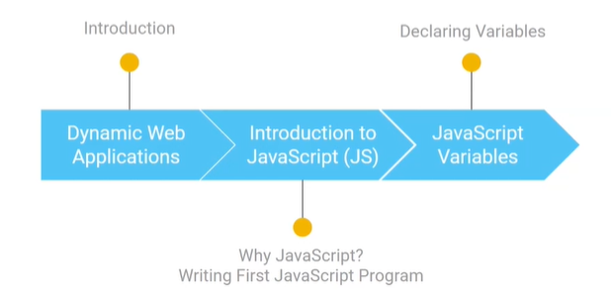

Intro to dynamic web application

* User specific personalized content in instagram
* User specific video recommendations
* Real time live cricket score updates
* Real time Statistics update
* Real time Google maps shows red when traffic is more , start & end destination
* User interactivity form data validations

How can we build dynamic web applications

* Browser = client , req server

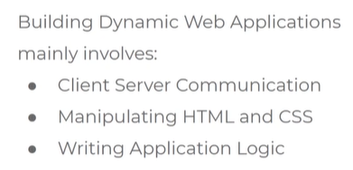

How to achieve the above 3?

* Two ways: js and web assembly
* We use js because it so popular, almost all browser’s understand JS
* Web assembly is recent language
* Almost all companies use JS

HTML, CSS, JS

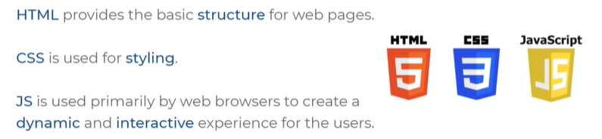

JS

* Mostly used in client side
* Can be used in both server and client side
* Server side we have so many other languages like python, java

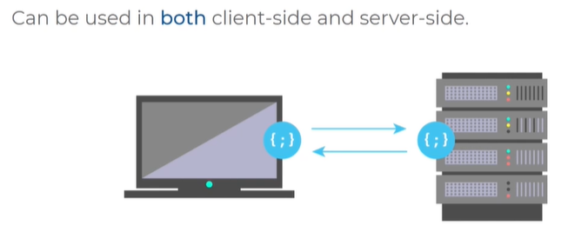

What can we do with JS

Build User experience

* Animations
* Live dashboards
* Browser based games

Programming with JS

* 1st program dislay hello world

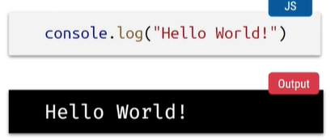

JS VARIABLES:

* Variables are like container to store values
* Variables can be string, int, float

How to declare variables in js

* Use keyword let
* Let is the keyword
* Message is the variable name

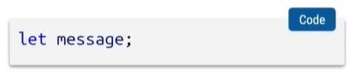

Assigning value to a variable

* Below are the 2 ways
* Declaring variable and defining value in one statement
* Declaring variable semicolon and defined value with assignment operator
* = is assignment operator

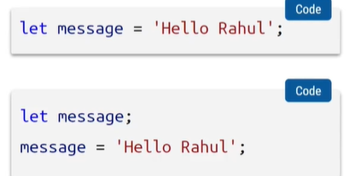

Printing a variable without assigning a value

* Declared variable but not assigned value gives undefined as output

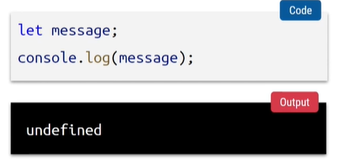

**DOM & EVENT FUNDAMENTALS**

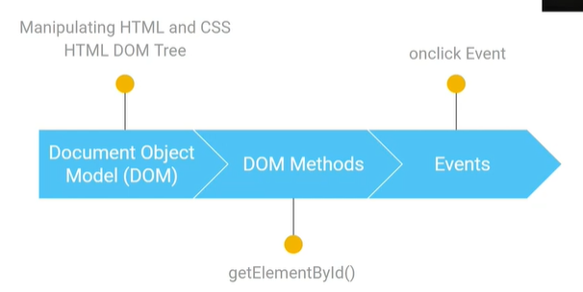

DOM DOCUMENT OBJECT MODULE

* There are muntiple types of DOM’s
* Here we are learning HTML DOM

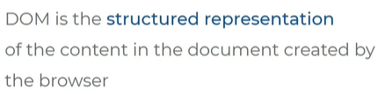

HTML DOM

* Oka HTML document ni manam browser ki ichinapudu, ah browser tree ropam lo representation ni pettukuntundi, ala tree structure lo pettukodam valla manam JS ni use chesi structure, style, content ni design cheyachu

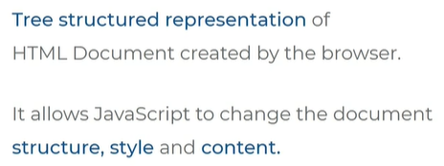

TREE REPRESENTATION:

* Each box is called as node or object

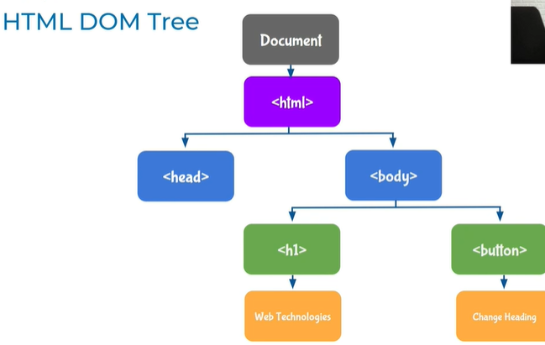

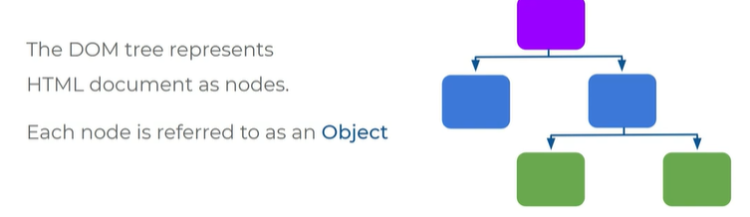

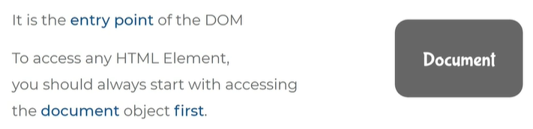

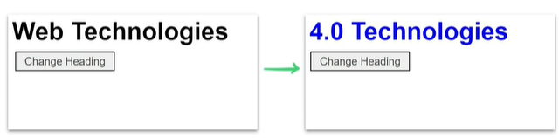

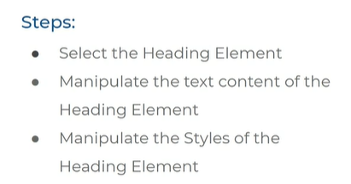

SELECTING THE HEADING ELEMENT :

* Id attribute in HTML to select a heading uniquely
* Id attribute value is headingElement

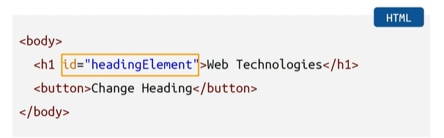

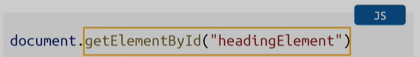

* Selecting heading element in js
* DOM entry point is document object / document node
* getElementById() is a method we use to select id in html

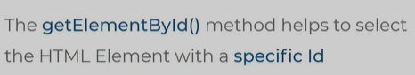

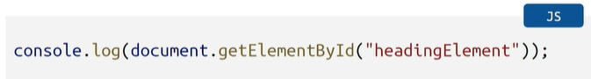

* console.log pedithe output lo print avthundi

print aye output

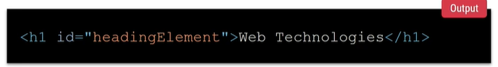

MODIFY THE HEADING ELEMENT TO 4.O TECHNOLOGIES

* to do this use textContent property and modify the text
* remove console.log

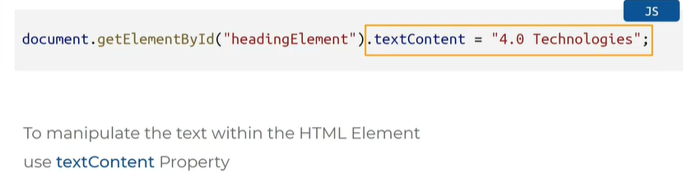

MANIPULATING THE STYLES:

* dot.style dot.color = blue
* main heading changes its color to blue
* text color change avthundi blue color lo

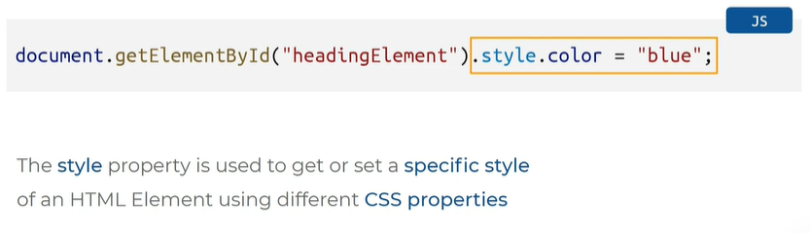

MANIPULATING USER ACTION:

* for this we use concept EVENTS

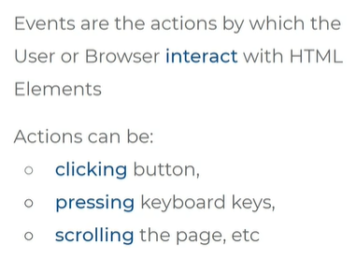

ON CLICK EVENT

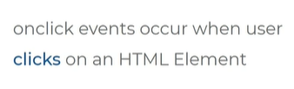

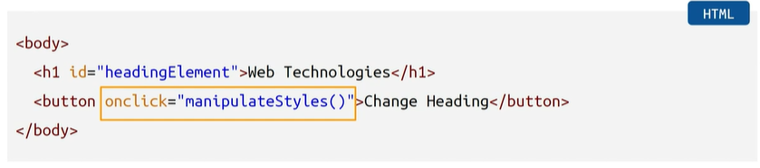

* on click ane attribute ki value manipulate styles of
* manipulate styles ane function ni call chesthunnam
* def and call a function concept
* on click lo ey peru ayithe pedathamo ah peru thone function call cheyali

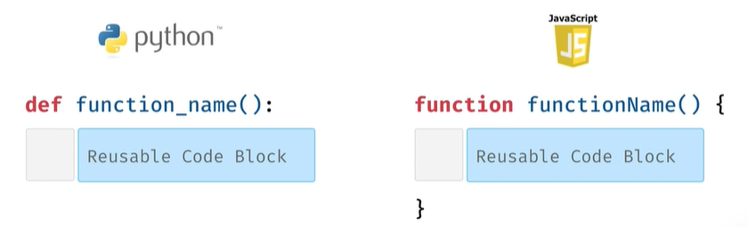

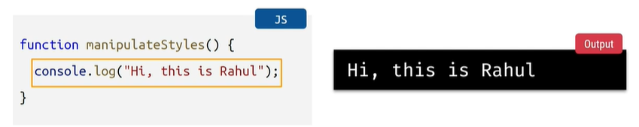

HEADING, TEXT CONTENT CLICK CHESAKA MARALI ANTE

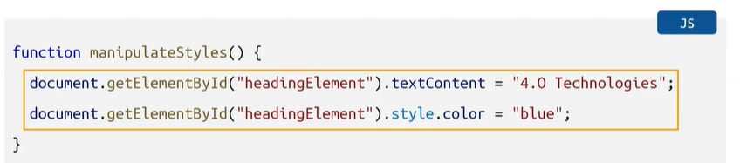



CAT AND LIGHT EXAMPLE

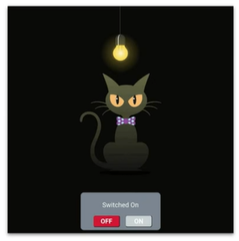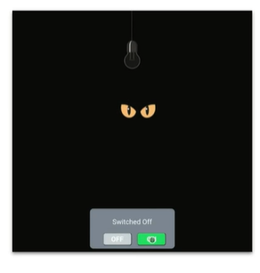

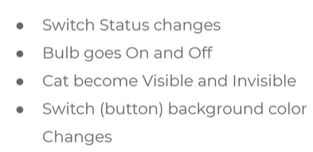

Default code – by default switched on state lo undhi

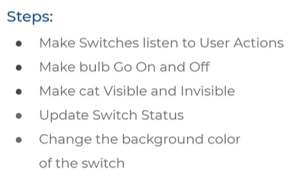

**Make switches listen to user actions**

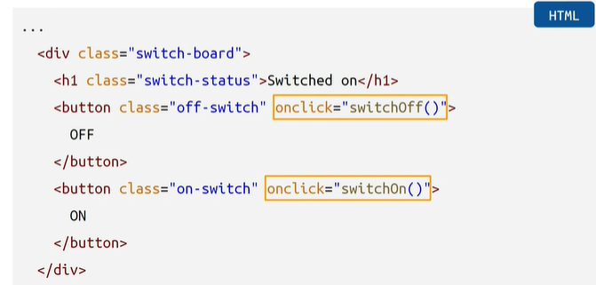

1. Make switches listen to user actions with onClick event in button , onClick attribute ki values switchOff and on ani rendu functions ni call chesam
2. Rendu buttons lo onClick rasthunnam
3. Js lo function define chesi call chestham
4. Denilo functionality rayali next step lo

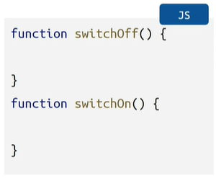

**MAKE BULB GO ON AND OFF**

E functions lopala code rayali

Ekkada functionality rastham functions lo

Switch off click chesthe bulb off avvali image change cheyali

Switch on click chesthe bulb on avvali image change cheyali

Specifying id = bulb switch on ayina image ni select cheyali

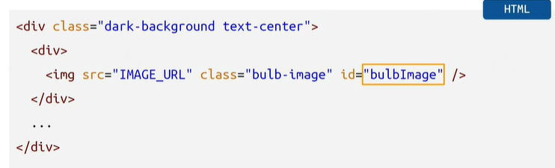

Changing the bulb images sources

Id bulb image ane class pakkana ivvali lopala ivvali

Swtichon = on lo unna bulb image url

Swtichoff = off lo unna bulb image url

Src = source attribute lo bulb image url’s paste cheyali

<https://d1tgh8fmlzexmh.cloudfront.net/ccbp-dynamic-webapps/bulb-go-on-img.png>

<https://d1tgh8fmlzexmh.cloudfront.net/ccbp-dynamic-webapps/bulb-go-off-img.png>

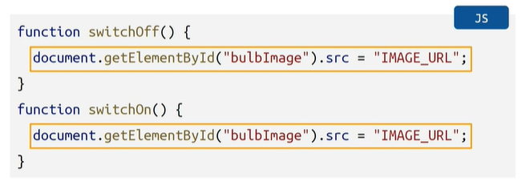

**MAKE CAT VISIBLE & INVISIBLE**

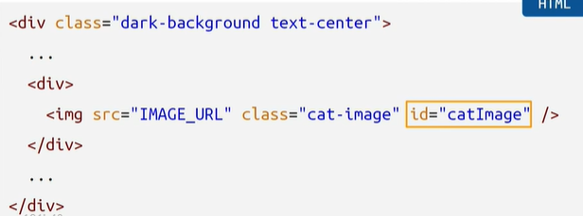

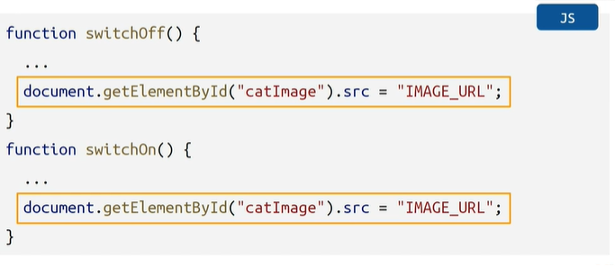

Specify id in HTML after the class name cat-image

Change image sources

Switch off image url

<https://d1tgh8fmlzexmh.cloudfront.net/ccbp-dynamic-webapps/cat-eyes-img.png>

Switch on image url

<https://d1tgh8fmlzexmh.cloudfront.net/ccbp-dynamic-webapps/cat-img.png>

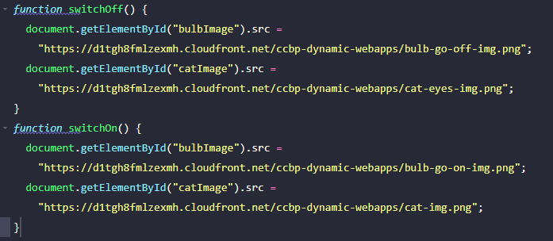

**CHANGING SWTICH STATUS**

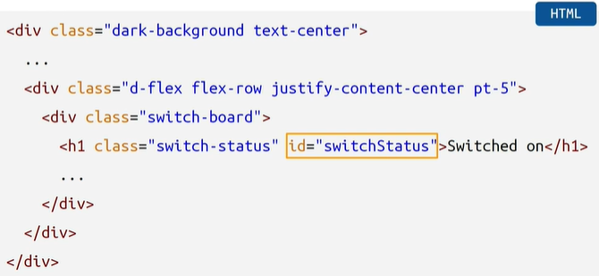

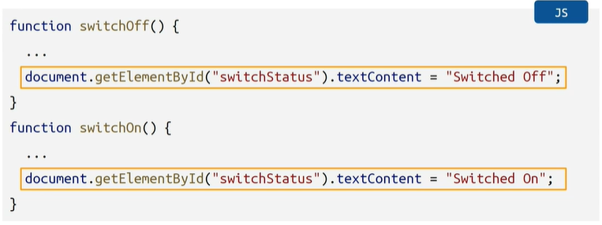

H1 heading class pakkana id specify cheyi

Js lo textcontent update cheyi

Specified id and called function

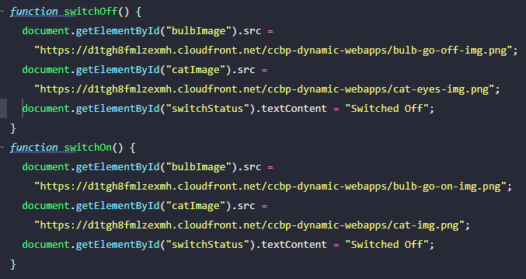

**CHANGING COLORS OF BUTTONS**

Specify id in buttons

Style lo background color property use chesthunnam

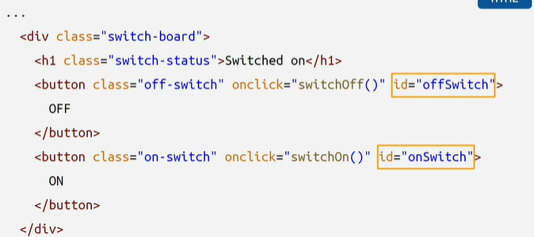

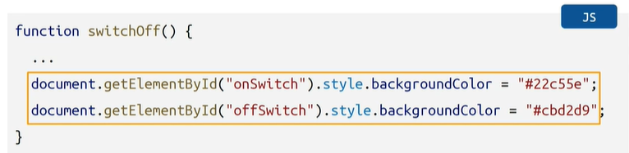

Specified id in button and called function

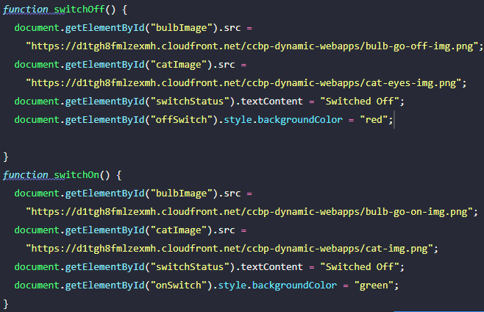

**PRIMITIVE DATA TYPES CONDITIONALS**

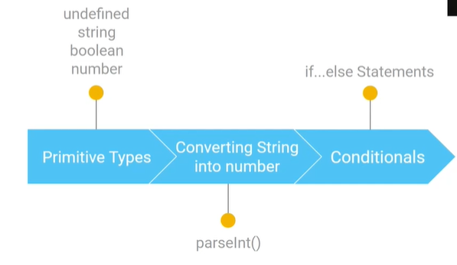

UNDERSTAND WITH COUNTER APPLICATION

VALUES ARE OF 2 TYPES:

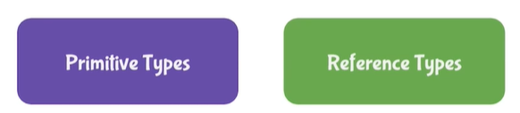

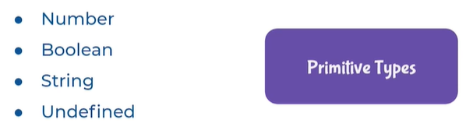

TO CHECK TYPE

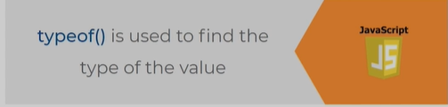

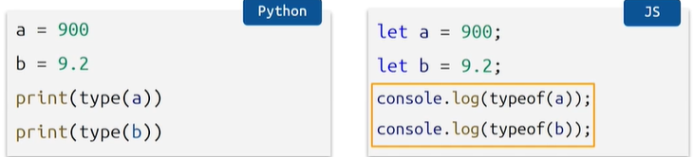

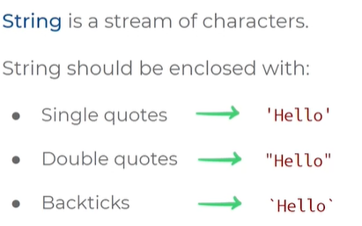

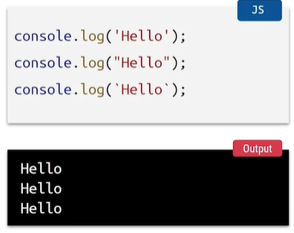

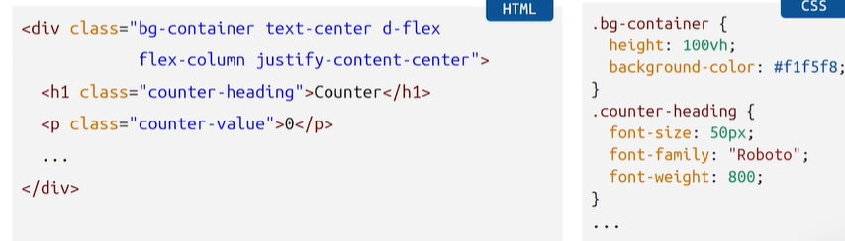

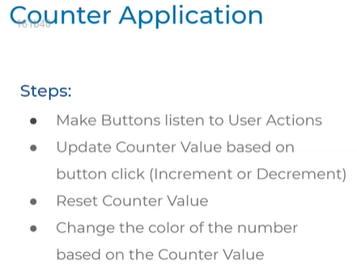

Make button user actions

Increment by 1

Decrement by 1

Reset

Changing colors

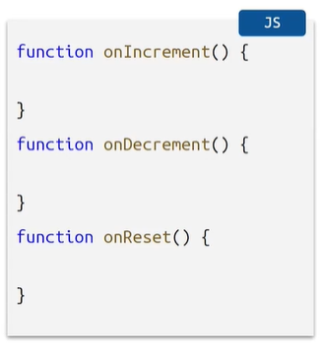

**Define on click events for buttons**

Call these functions

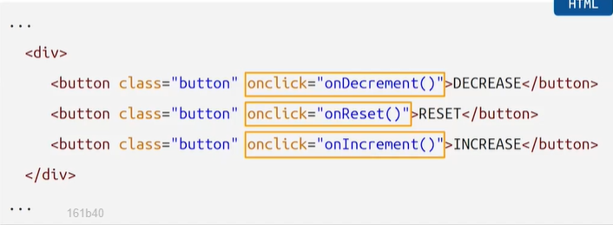

**Specify id in paragraph element**

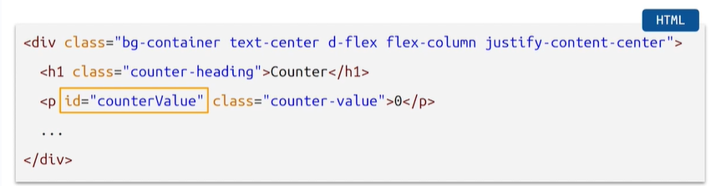

Paragraph element lo value 0 ani intialsie ayindi

E 0 ni manam modify cheyali ante dom-get element by id – to identify this id – id create chestham counter value ani

E id tho unique ga identify chestham

**Accessing counter element with let**

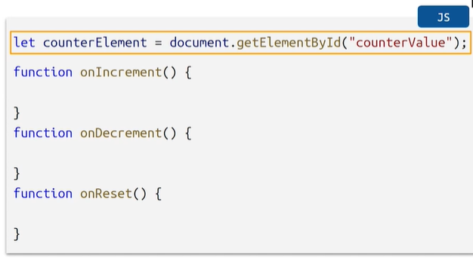

Accessing counter element ki manam oka value pettukuntunam

Value enti ante document…..

Counter value anedi paragraph element lo manam define chesina id name

**Increment Value**

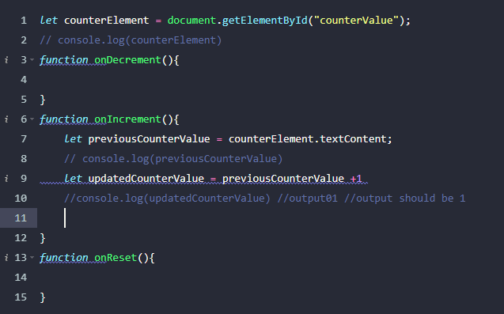

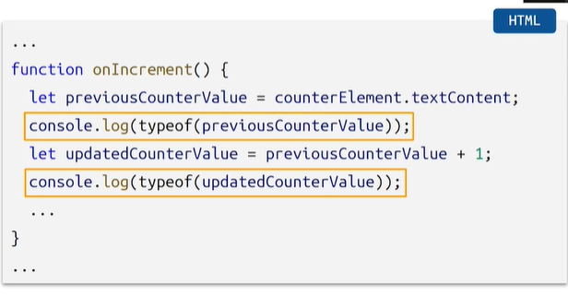

These are string type

0 and 1 are getting concatenated and we are seeing undesired behavior

**CONVERT A STRING TO INTEGER**

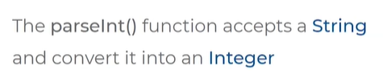

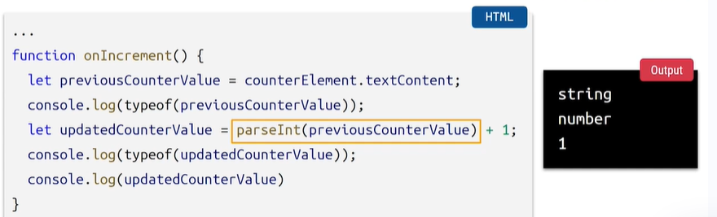

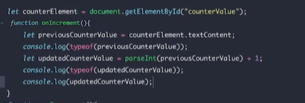

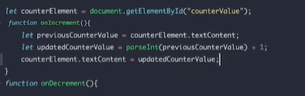

parseInt to string format ni integer ga convert chesamu

**DECREMENT**

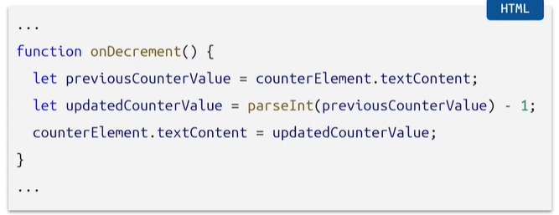

Antha same code -1 ani change cheyali anthe

**DECREMENT**

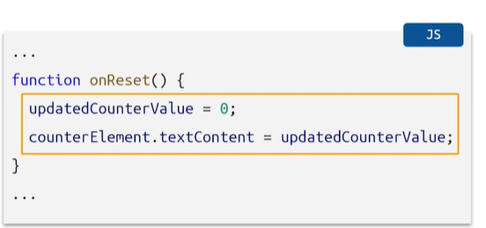

Zero avvali

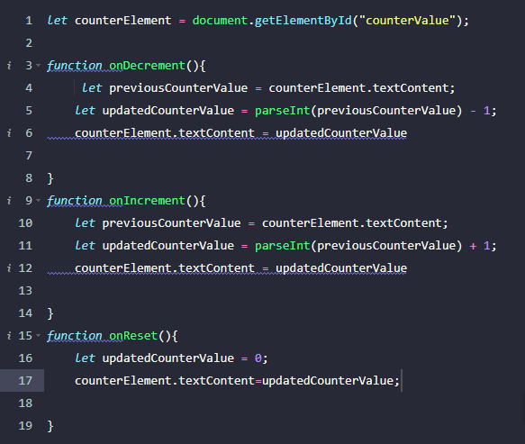

CONDITIONAL STATEMENTS

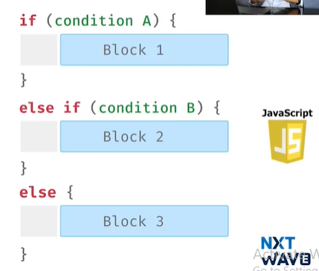

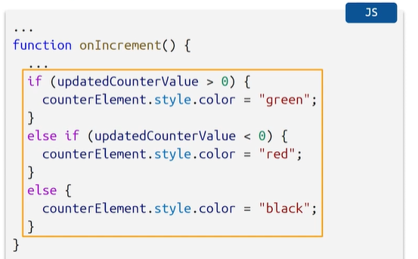

**INPUT ELEMENT AND MATH FUNCTION**

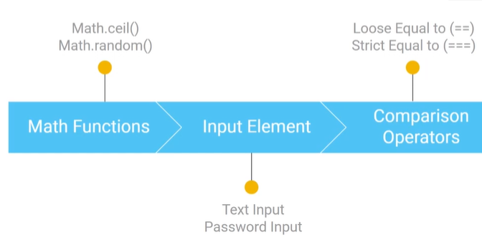

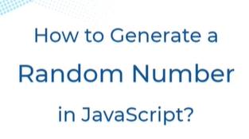



* Gives a floating point value

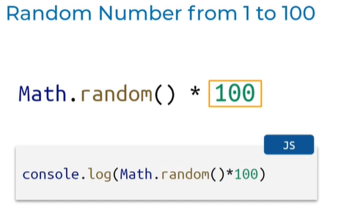

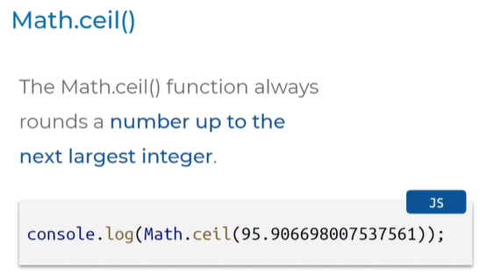

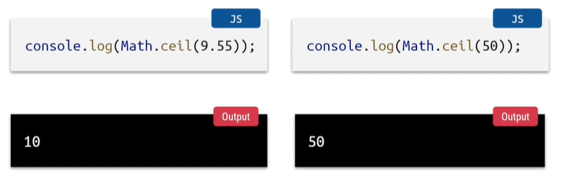

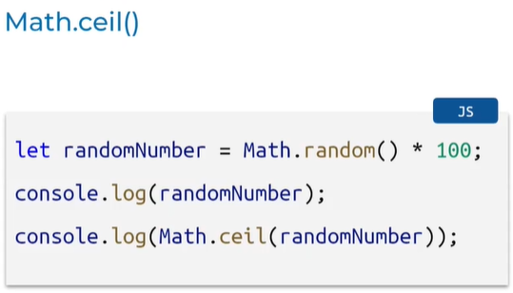

***HOW TO TAKE INPUT FROM USER***

Uses html input element

Different types of input elements

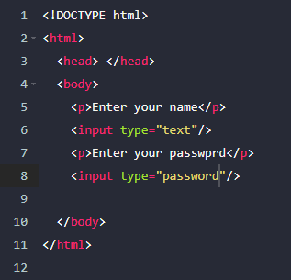

HOW TO ACCESS THE INPUT TAKEN FROM USER WITH JS

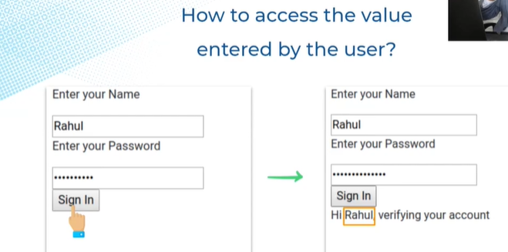

**Designed this first :**

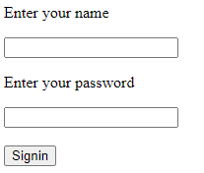

Name mana input , name ane input lo unna value ni access cheyali ante js lo value property use cheyali.

Use value property to get the value of the HTML input element

Paragraph, heading ki textContent ane property use chestham

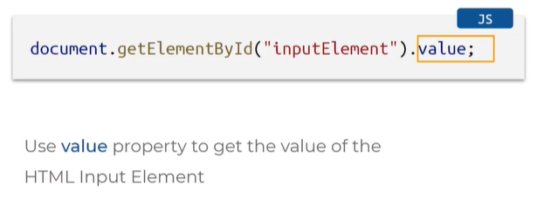

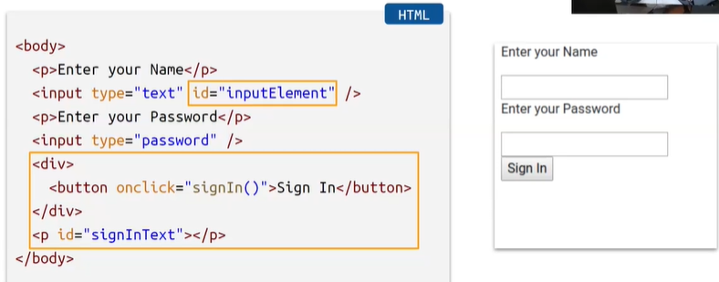

* Name input ni unique ga identify cheyadaniki id create chesam
* Html lo button create chesanu
* OnClick event lo signIn ane function call chesanu
* Button click chesthe hi name verifying ur account ani ravali
* Paragraph element is created and modified with JS using id and id lo signInText ani rasamu

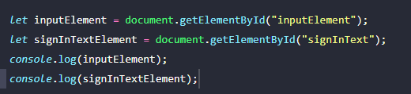

* Html lo define chesina id js lo read cheyali ante e process follow avvali

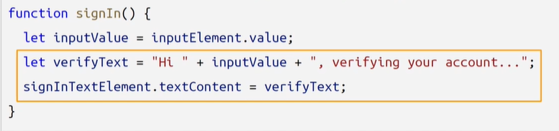

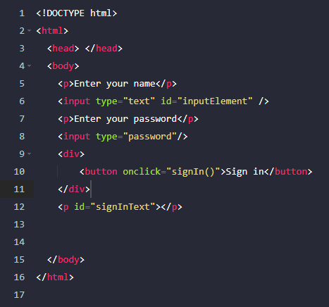

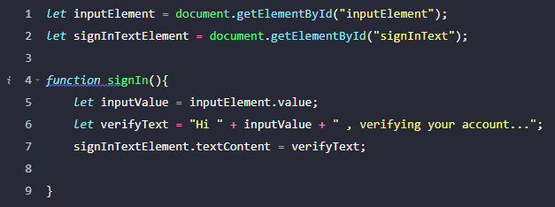

**ARRAYS AND OBJECTS**

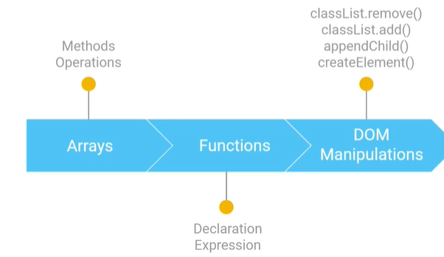

Arrays = Data structure

Data structure = Store and organize data efficiently

**Arrays created by square braces, elements separated by comma**

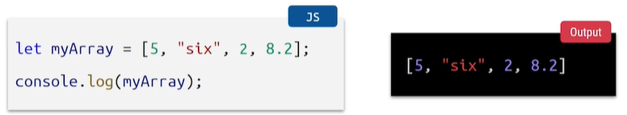

**Access an array item with index**

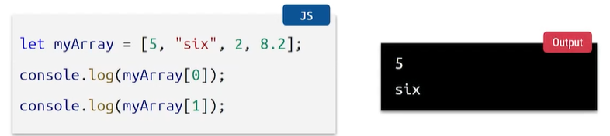

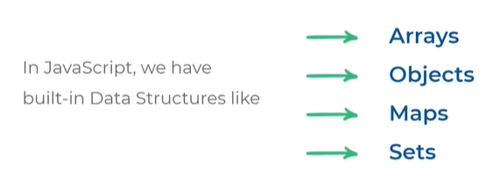

**Modify an array item**

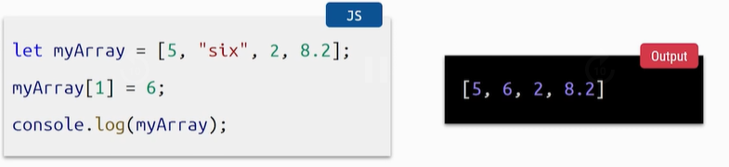

Find length/ no.of items in array

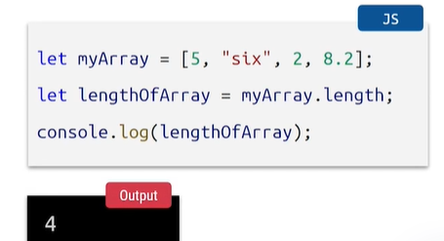

How to add and remove items in an array

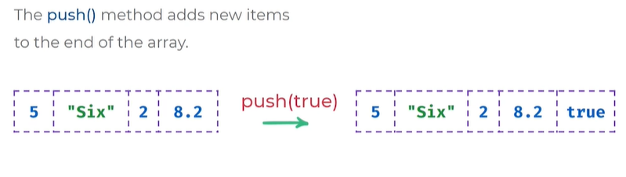

* Push(true) ane value last lo ad ayindi
* Push () use chestham oka kotha value ni add cheyadaniki

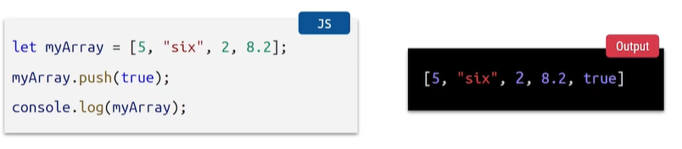

**Remove:**

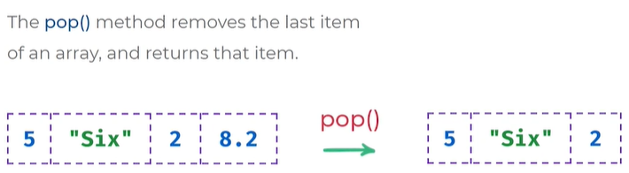

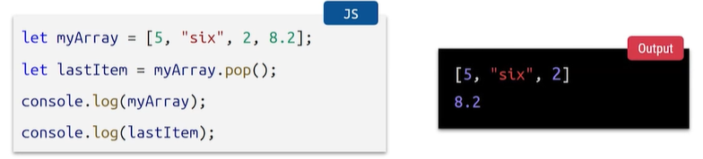

* Pop() ane method call chesthe last element delete avthundi

**DOM Manipulations: create HTML heading element**

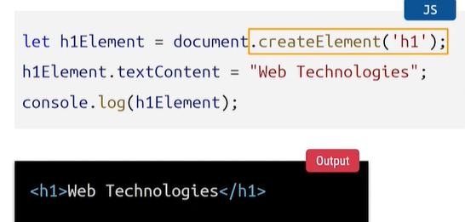

* Document ane object ki createElement ane oka method undhi
* E createElement ane oka method tho manam oka html element ni create cheyachu
* createElement ane oka method lo brackets lo html tag name ivali
* ekkada tag ni h1Element ane variable lo store chesthunnam
* .textContent to keep content we kept web technologies

**Appending to document body object**

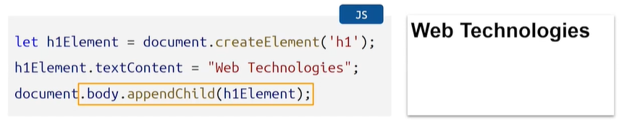

* Mana main html code lo body ane tag untadi danilo manam code rastham
* Js lo body.appendChild ane method untadi
* Document.body = ante body ane element ni thiskosthunnam
* Append ante add cheyamani cheothunnam h1 element ni

**Appending to an existing container element**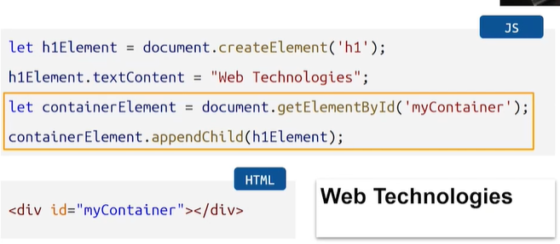

* Html lo div ane oka container element ni add chesam daniki oka id ichamu
* Variable create chesi append chesam
* appendChild ane method use chesi container lo pettam

**Create and append button element**

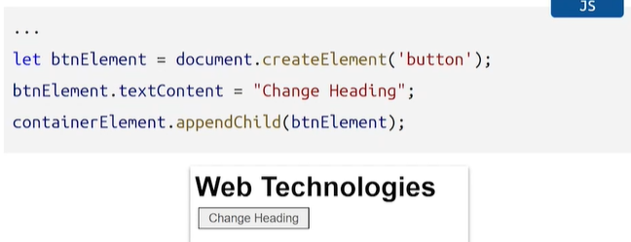

* Inthaka create chesina container ki button eleent add chesam
* Creat element lo button tag pettam
* Daniki text assign chesam

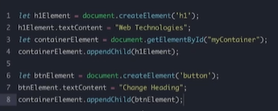

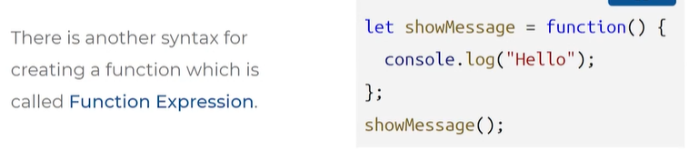

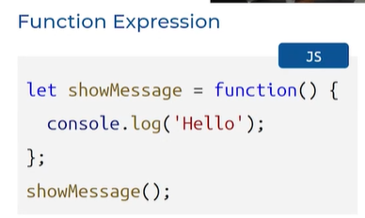

**Show msg = variable**

**Functional Block of code**

**Function called**

**This is another syntax**

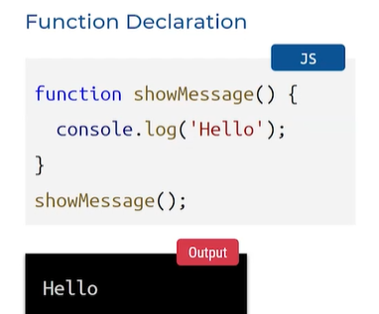

Edi epati daka use chesam

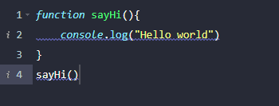

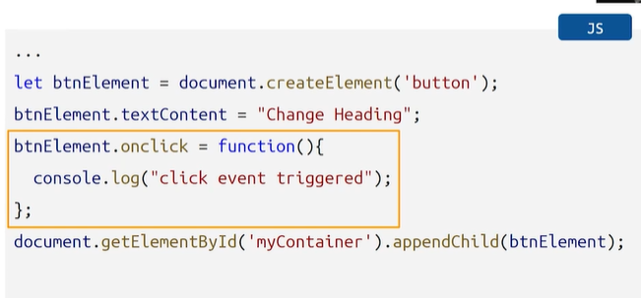

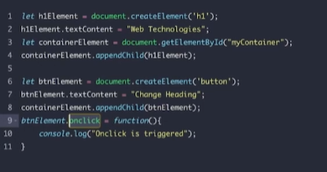

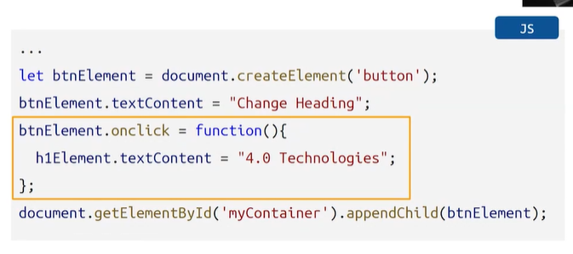

**Button click chesthe 4.0 technologies ani ravali**

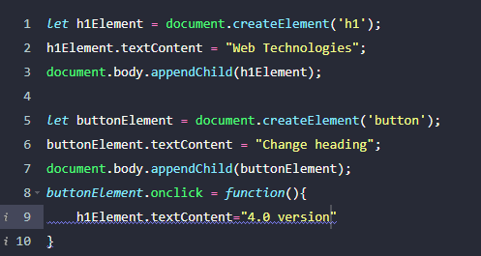

**Heading styles based on user actions**

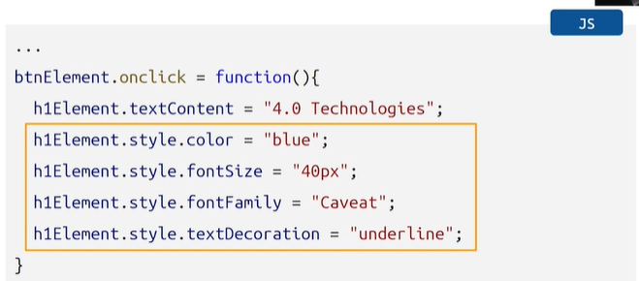

**ADDING CLASS NAME TO JS DYNAMICALLY**

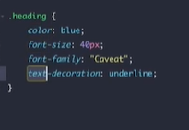

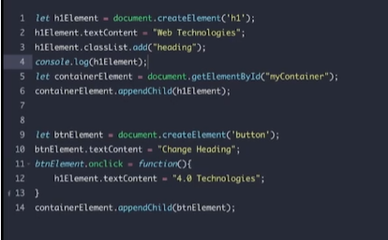

CLASS LIST DOT REMOVE METHOD

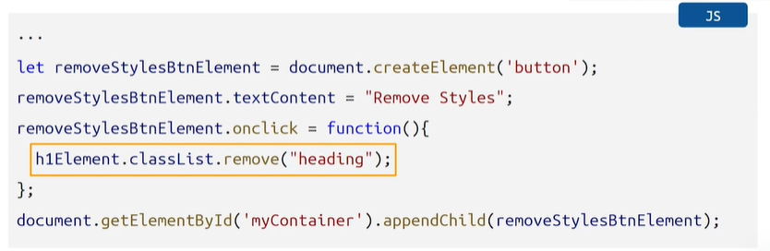

Css lo manam class names ni delete cheyachu e 2 methods tho classlist.add() and remove()

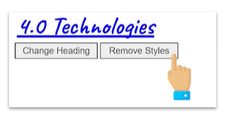

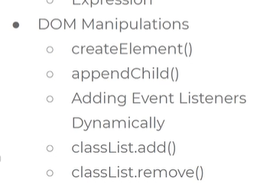

1. **Creating html elements**
2. **adding them to body section of html**
3. **Adding the above body to container**
4. **The above process create button**
5. **Defining and calling function is called as function declaration**
6. **Function expression**
7. **Button onClick function calling in js**
8. **Add color, FS, FF,text decoration to button in js**
9. **Classlist.add()**
10. **Classlist.remove()**

**OBJECTS**

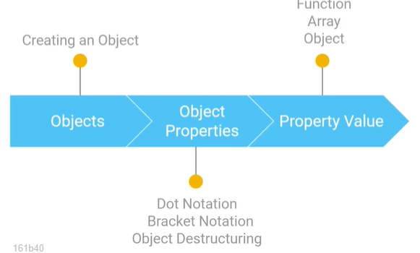

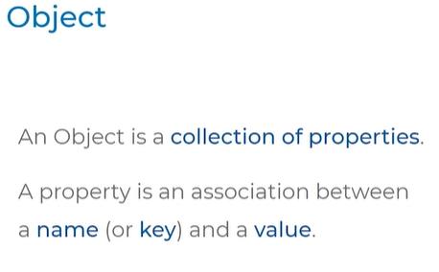

**KEY AND VALUES COMBINATION IS CALLED AS OBJECT , keys are also called as identifiers**

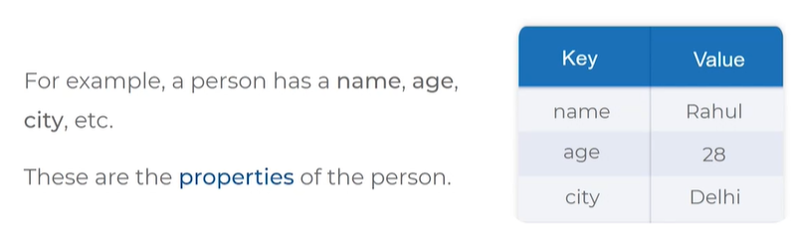

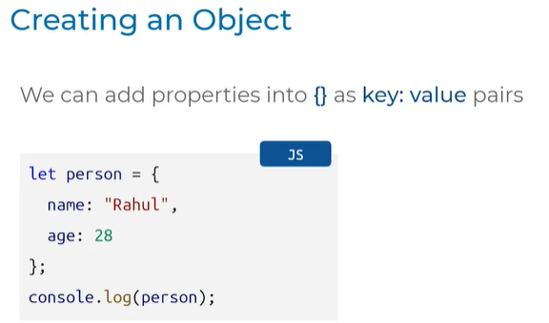

* Person = object
* Property 1
* Key = name
* Keys are also called as identifiers
* Rahul = value
* Property 2
* Age = key
* 28 = value
* We can add muntiple properties

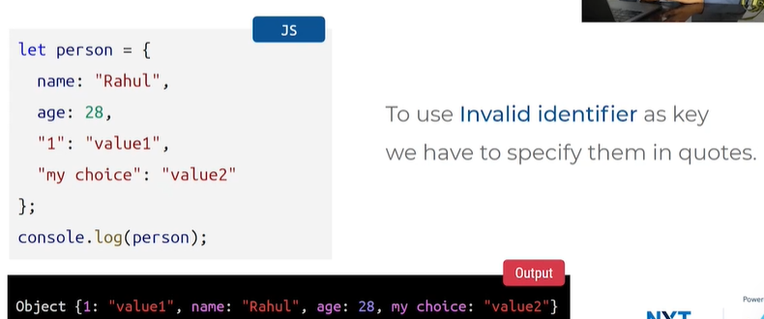

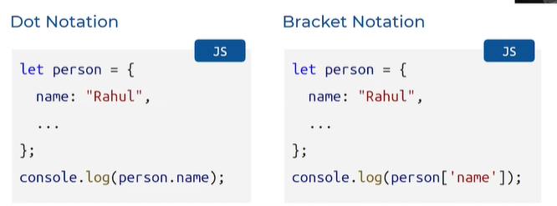

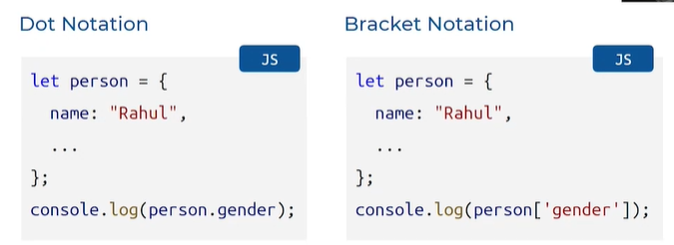

1. Accessing non existing properties
   1. dot notation (undefined)
   2. bracket notation (undefined)
   3. 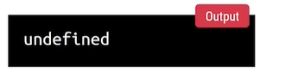
   4. Leni property access cheyali ani chusthe undefined ani vasthundi

OBJECT DESTRUCTING:

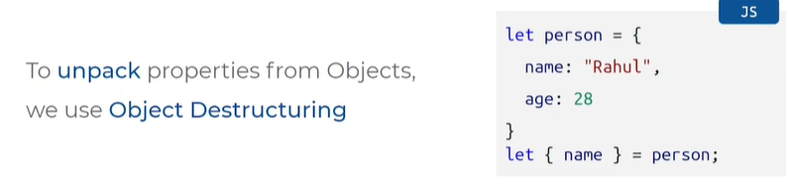

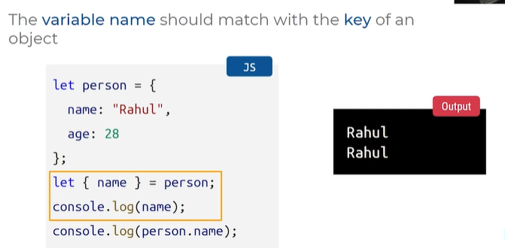

* Person ane object properties ki values variables ki assign cheyali ante use OBJECT DESTRUCTING.
* Key name value rahul
* Key age value 28
* Let flower braces lo name ani pettam = person
* Person ane obj lo nunchi name ane key ki value em undo Danni name ane variable ki assign cheyi antunnam
* Object key undali flower braces lo em variable pedathamo ah var name object lo undali

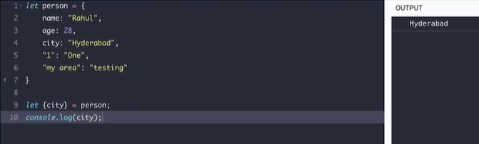

* Leni property ni access chesthe undefined ani vasthundi

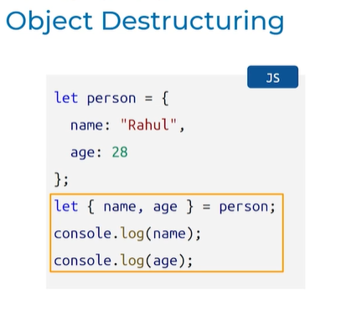

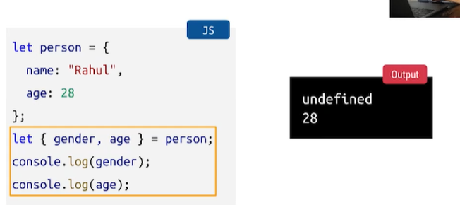



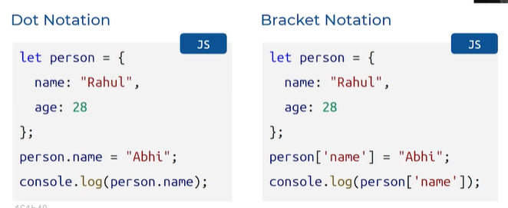

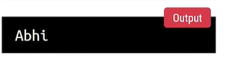

ADD NEW OBJECT PROPERTY

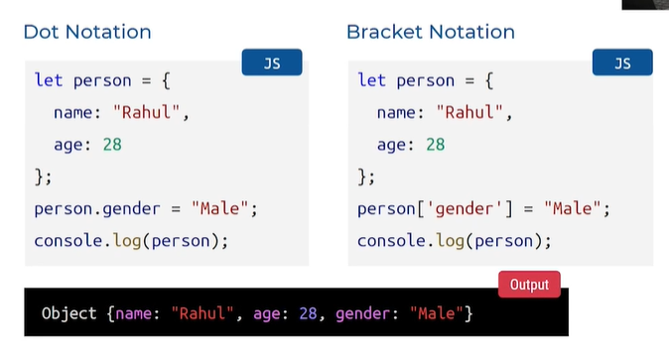

Epati varaku key ki values ga strings,integers ey pettam kani eve kakunda function, array,object kuda pettachu

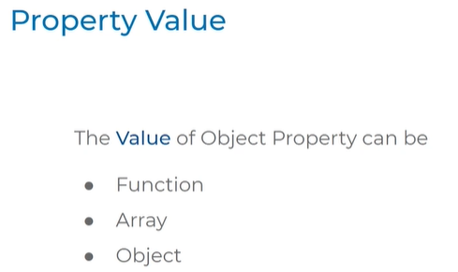

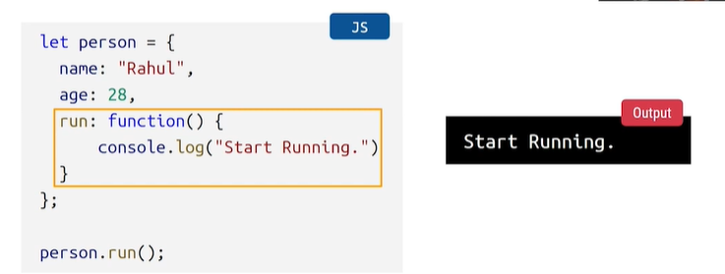

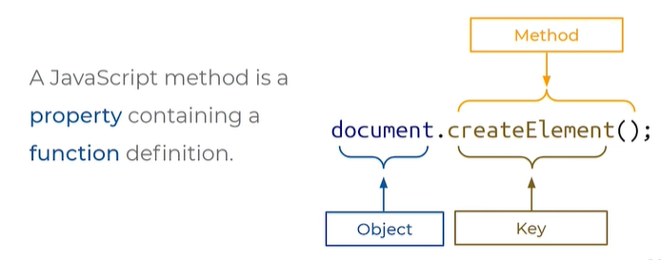

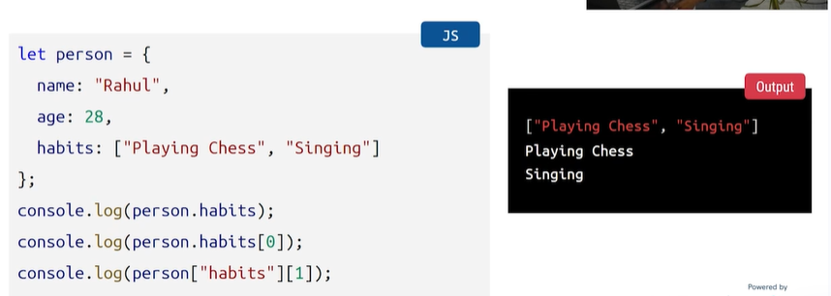

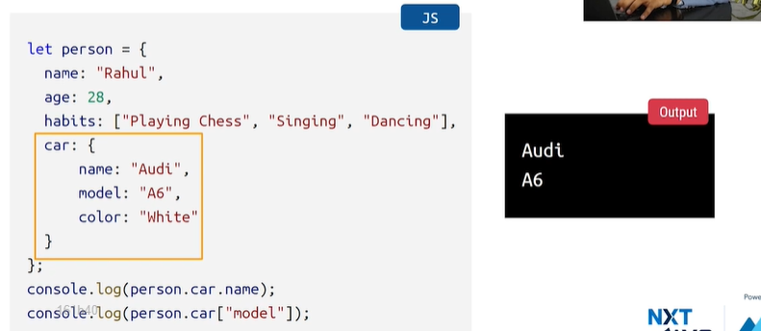

**TODOS APPLICATION**

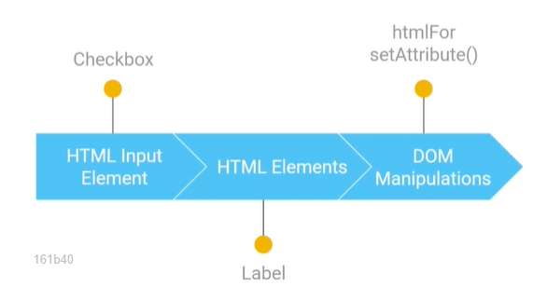

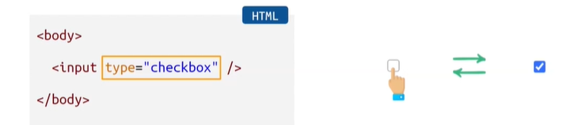

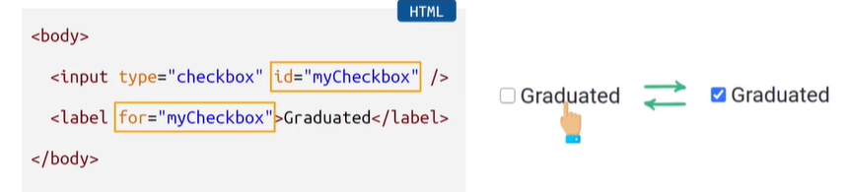

* Type checkbox specified id
* Label lo for attribute ki id lo pettina peru isthamu
* Graduated ani text rastham for attribute lo

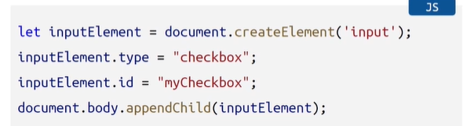

* Create element method thoti input element create chesam input tag pettam
* Variable create chesam
* Type attraibute ki value checkbox ani pattam
* Id attribute kuda my checkbox
* Body lo undali input element append chesam

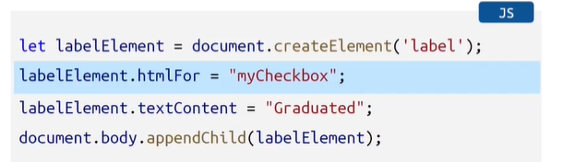

* htmlFor = set for attribute f is capital
* text add chesam = textContent
* body ki append chesam = body lo child laga untadi

INPUT & LABEL ELEMENT

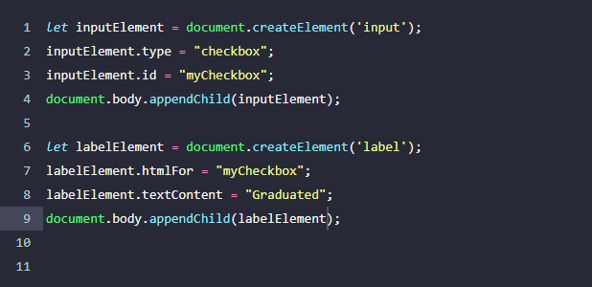

DOM manipulations set attribute method

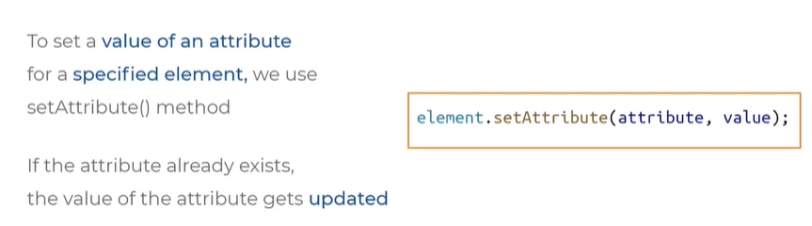

* html elements lo set attribute ane oka method undhi
* e method tho manam oka attribute ki value anedi set cheyachu
* attribute already exist ayithe epudu ichina otha value ni thiskuntundi
* label lo for attribute kakunda set attribute use chesthunnaru

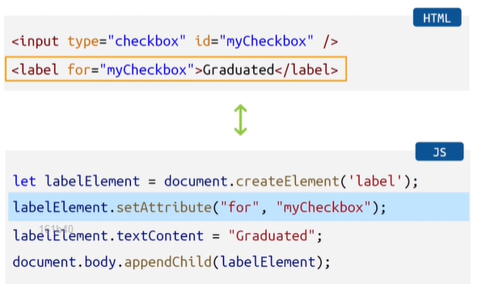

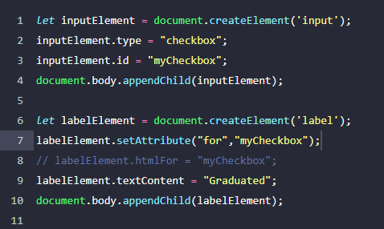

For ane attribute ki myCheckbox ane id specify chesam

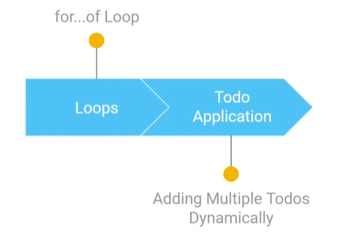

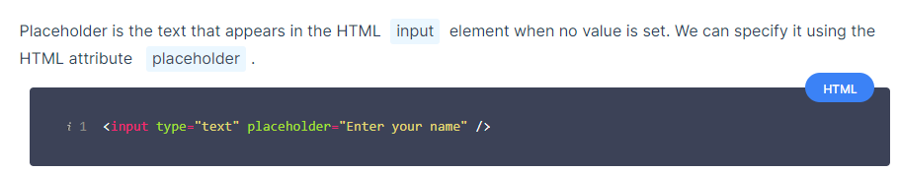

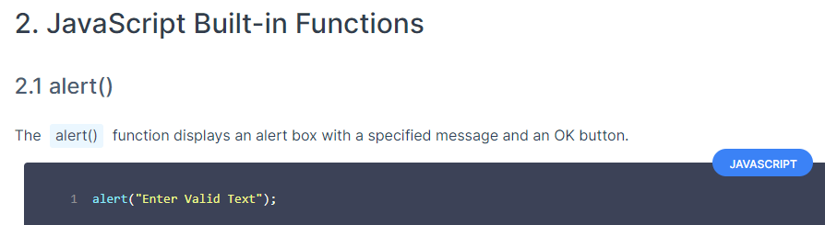

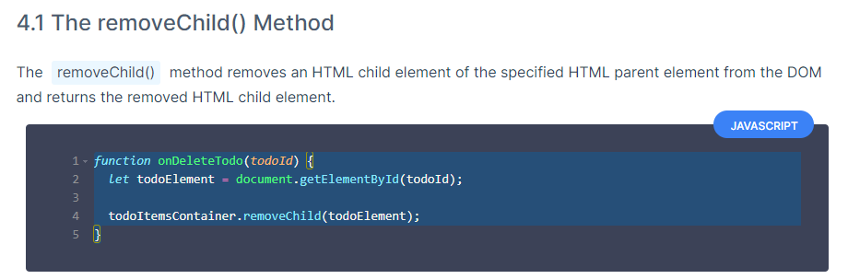

* remove child ane method
* removes element from another element
* just like append (adds)

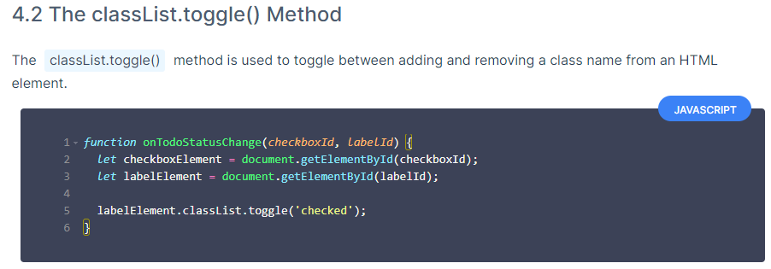

* Toggle anedi manam class name ichinapdu
* Class name anedi already ah element ki unte remove chesthundi
* Lekapothe nemo add chesthundi

**TODOS APPLICATION PART-2**

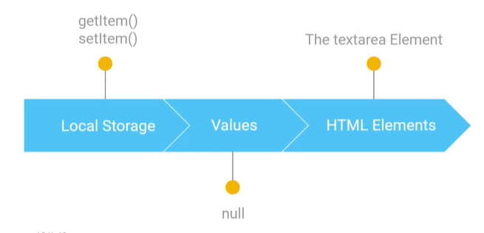

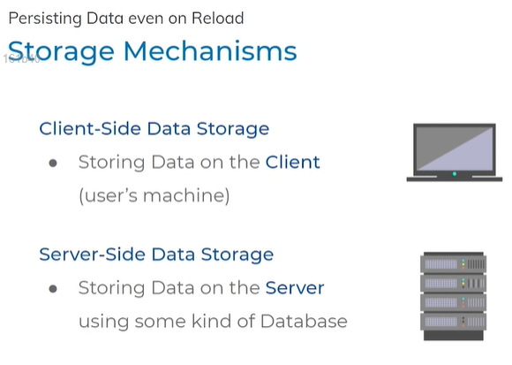

Client = mobile, browser which request data

Server side = data gets saved

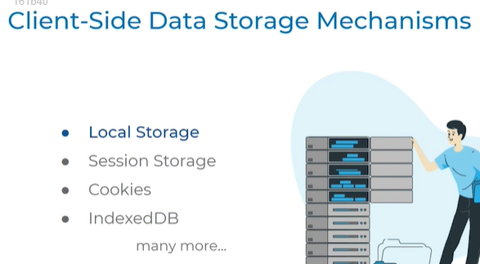

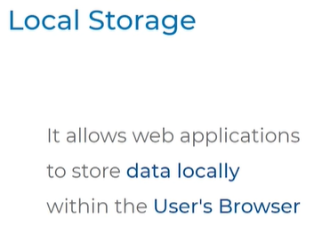

Within the browser the data gets saved

Manam delete chesthe gani delete avadhu

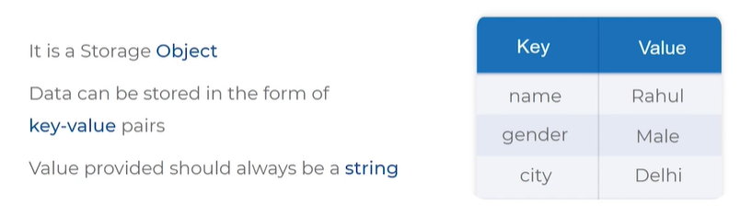

* Local storage is similar to a object
* Object lo manam key and value ni set chestham value either, string/int/boolean
* Local storage lo matram value laga string ni matrame ivagalam

Methods = set item , get item

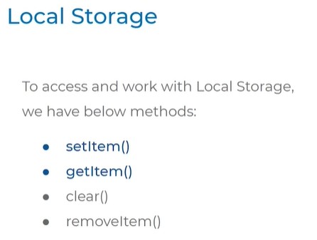

Syntax:

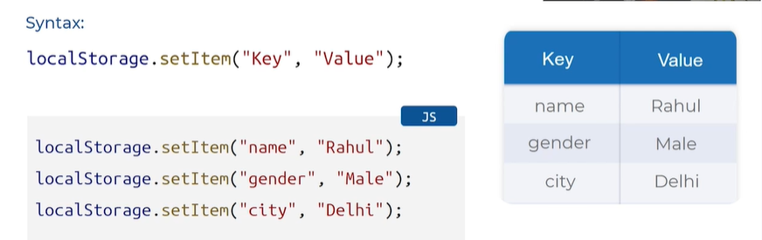

Edi syntax kani console lo kanapdadu

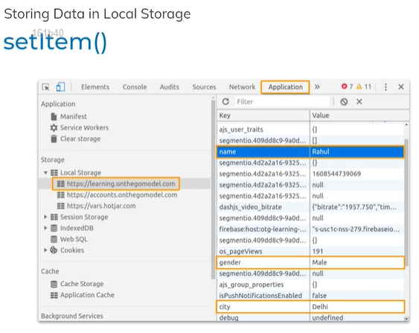

3 dots – more tools- developer tools- elements ,memeory….click on application in left side

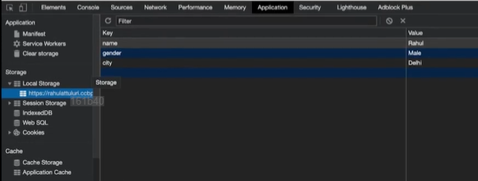

Ela developer tools lo ave avthundi

Syntax, local storage lo ela save avthundi anedi chusam

Epudu denni ela access cheyali????? getitem

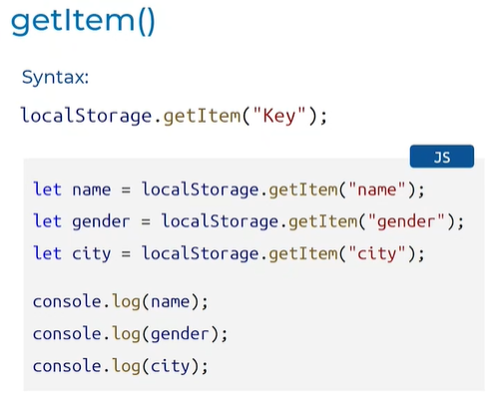

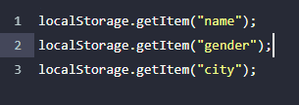

Edi syntax variable ni set cheyali get cheskodaniki

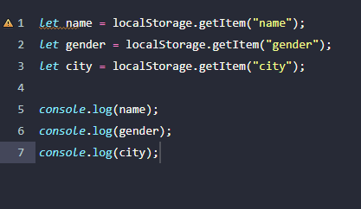

Manam sav echeyani item local storage lo save cheyani item ni get chesthe output null vasthundi

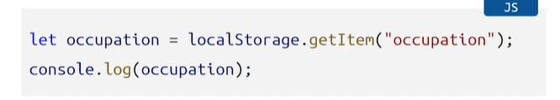

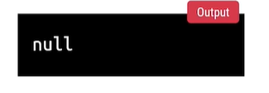

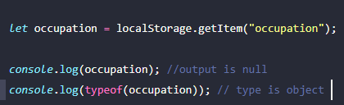

HTML TEXT AREA:

We can write input in multiple lines

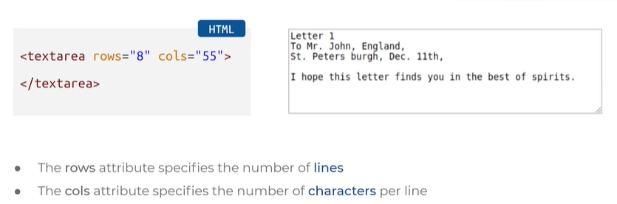

Rows = 8

Characters = 55

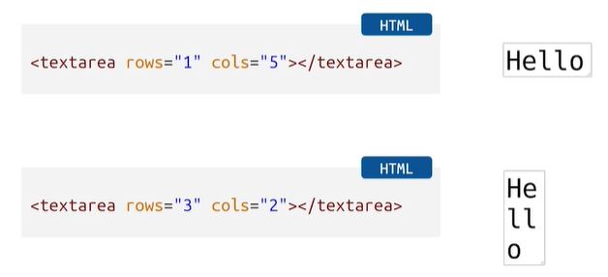

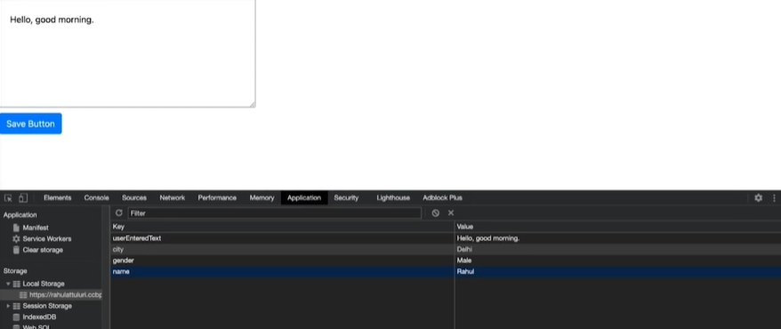

Local storage lo save avthundi

Reload ayithe kuda kanapadali store ayithe saripodu

Persistence kosam getitem use cheyali

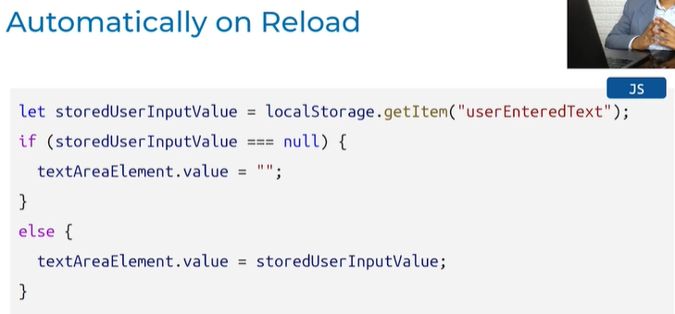

=== we are checking both value and type if both value and type are null show empty

Else value unte show value

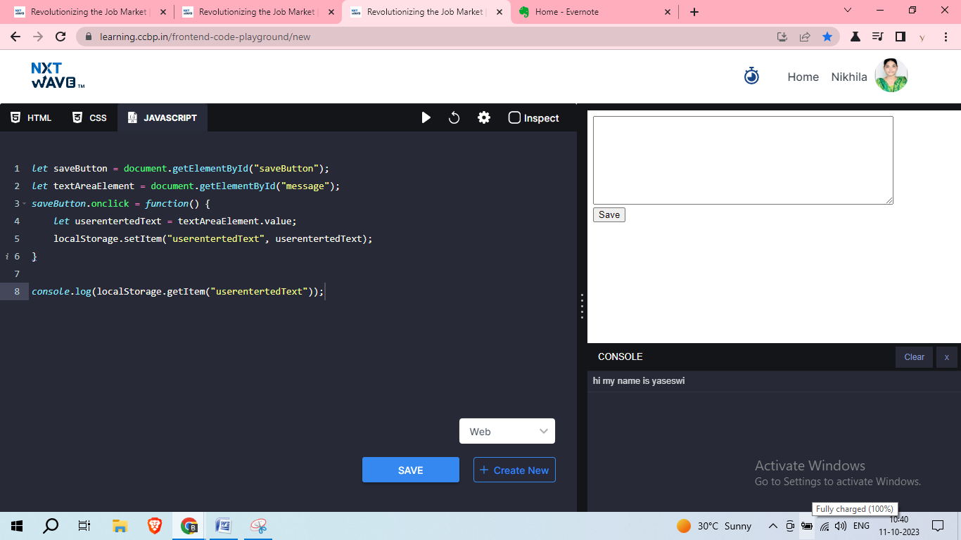

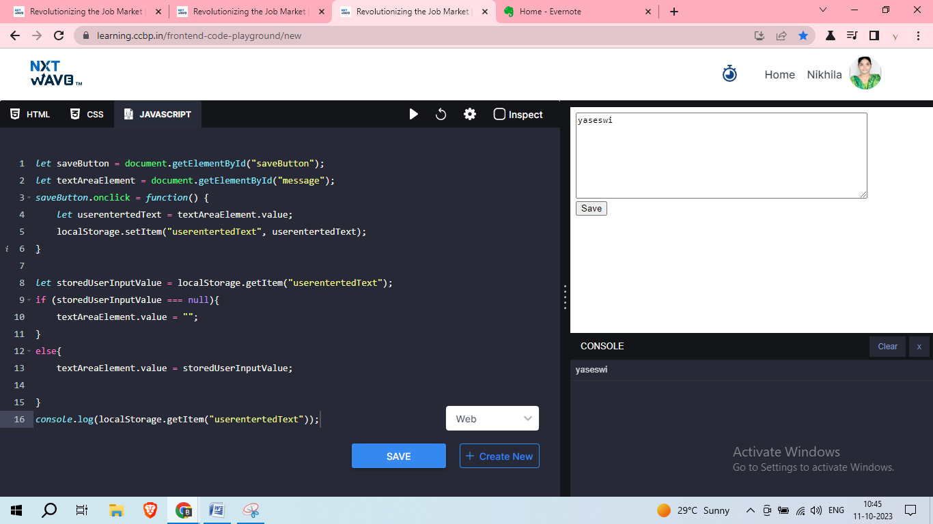

Step 1

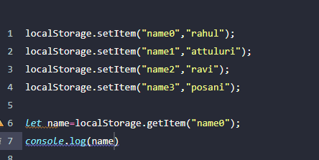

Step 2

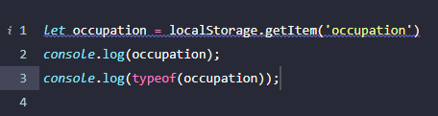

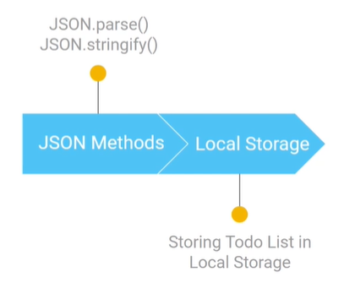

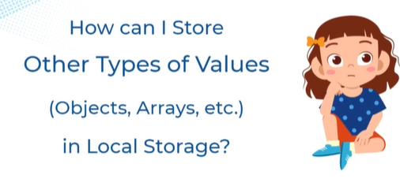



Json strings to store objects , arrays in local storage

Local storage lo strings ey save avthayi verevi save avvali ante json strings format use cheyali

Js object notation

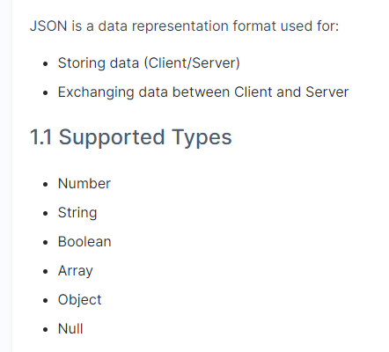

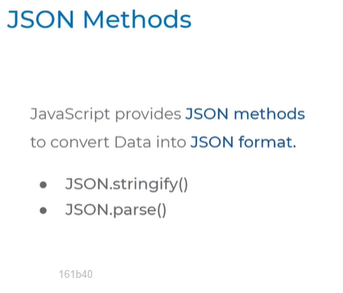

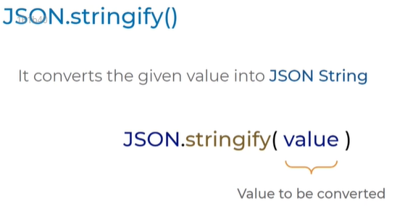

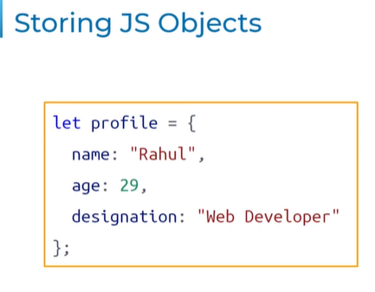

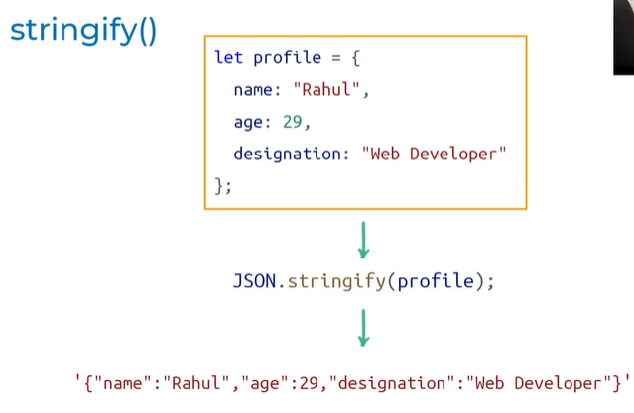

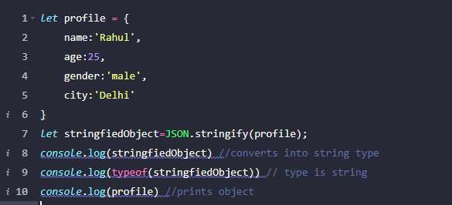

* Profile ane object ni create chesam
* JSON.stringify object value return cheyadaniki oka variable lo value ni pettukundam
* Console lo chusam em vasthundi ani
* Type kuda chusam
* Output lo quotes lo vasthundi
* String laga type kuda string

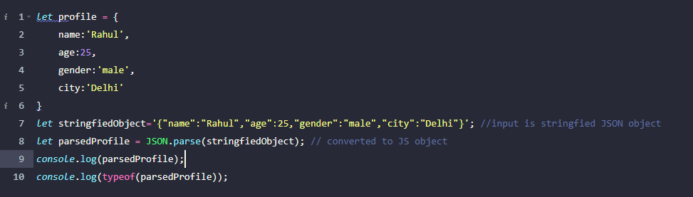

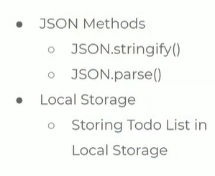

* JSON anedi oka data representation format
* E data ni manam client side or server side data ni store cheskodaniki use chesthamu , data communication kosam use chesthamu
* JSON methods stringfy and parse
* JSON methods ni use chesi local storage lo objects data strcture lo data ni store chesamu
* JSON parse method use chesi malli JSON file ga convert chesamu
* Local ga ela store cheyachu ela retrieve cheyachu

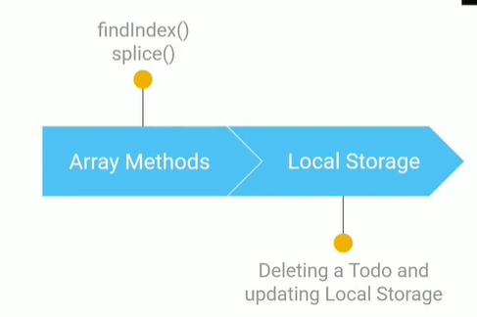

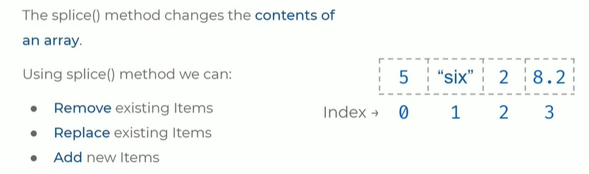

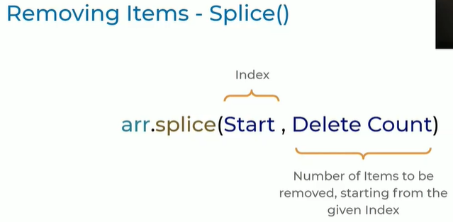

Start index nundi enni elements delete avvali anedi lopala arguments

Example:

REMOVE EXISITING ITEMS

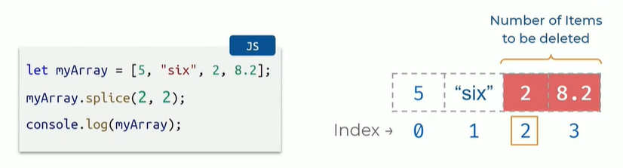

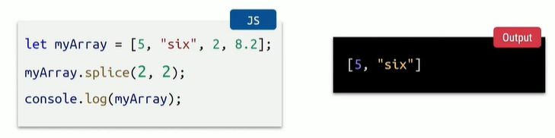

2,2 2 ane index nunchi 2 elements delete avthayi 2 index becomes one, next index becomes two

2,8.2 delete avthayi

(2,2) (3,1) (1,0)

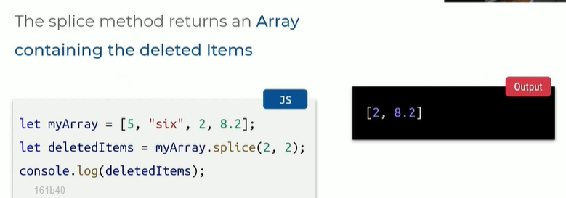

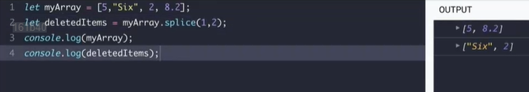

Zero-O ani pedithe ey elememts delet avvau

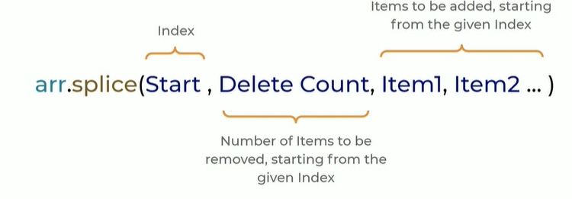

Start index

Ey elements delete avaudadu

Add avalsina items

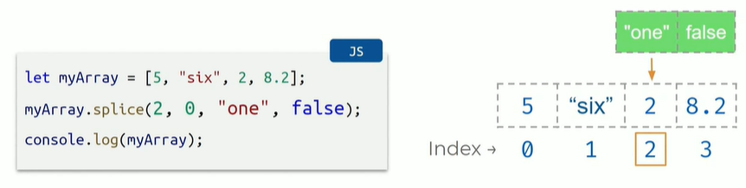

2 ane index degara one ane string and false ane boolean value ni add cheyamani chepthunnam

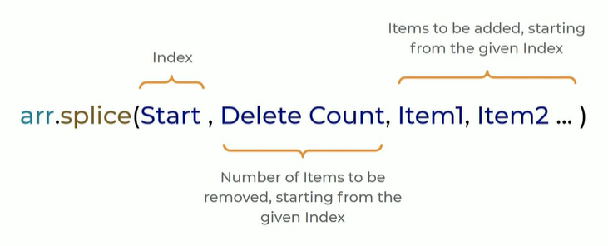

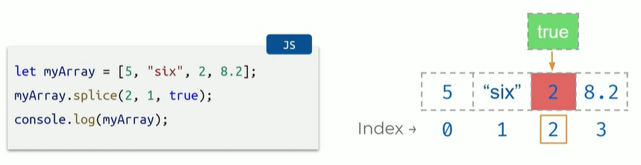

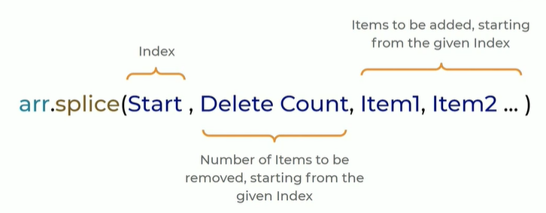

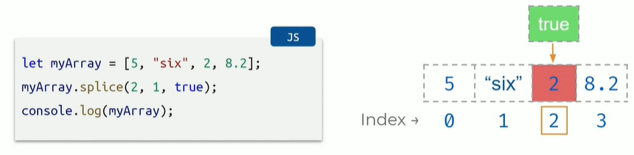

2 ane index lo 1st delete chesi replace with true



Find index in array so that we can del, add, replace

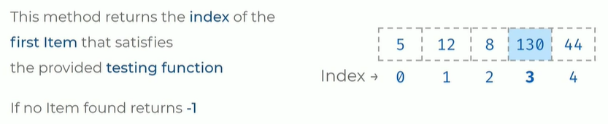

Syntax:

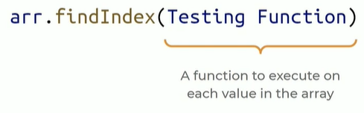

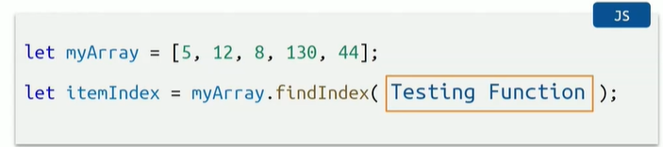

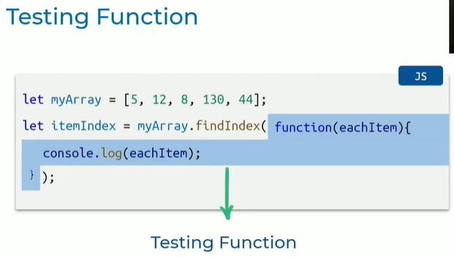

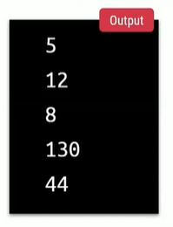

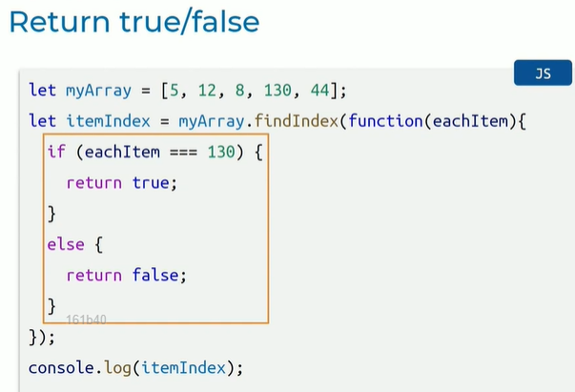

130 ane number array lo undha ledha unte true lekapothe false

=== value lekapothe – 1 anedi vasthundi

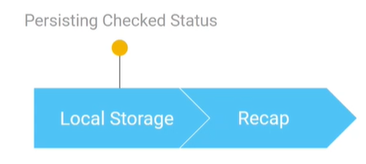

**FETCH AND CALLBACKS**

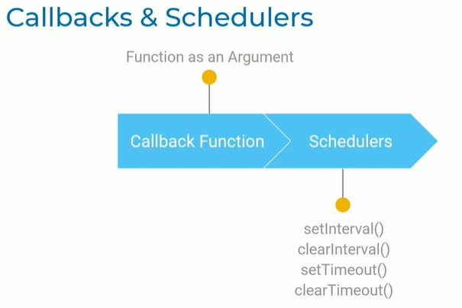

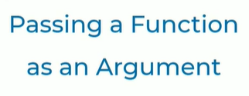

Oka function ni inkoka function ki argument laga pass cheyatam function argument antam

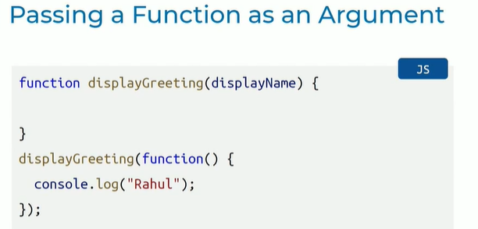

* Display name = argument
* Display greeting = function name
* When calling the function of Display greeting we are passing another function

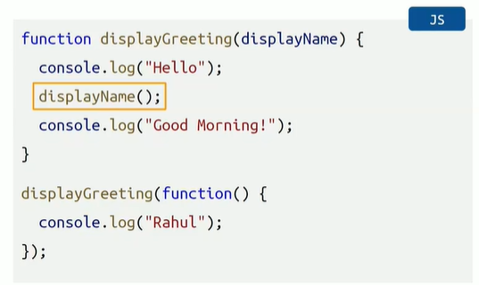

* Display greeting ane function ni complete chesam
* Console.log ani print chesam
* Displayname() ane argument ni / value ni function call chesthunnam
* Displayname() ni function ni call chesam

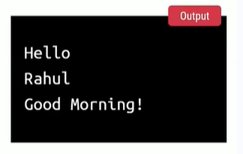

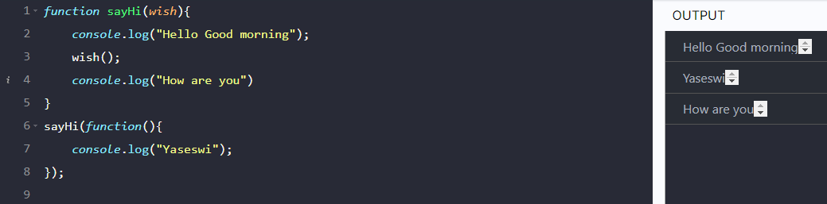

* sayHi = function
* wish = sayHi ki argument
* wish = argument called in sayHi function
* sayHi function ni call chesam wish ane argument ki value laga inko function ni call chesam

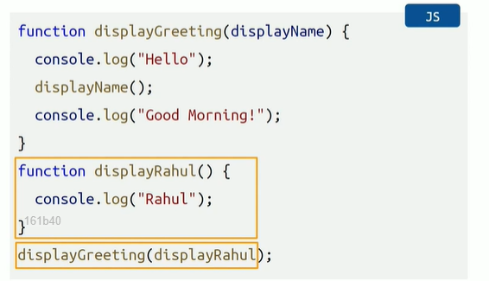

epudu deni lopala normal ga oka function ni declare cheyi

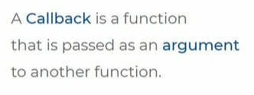

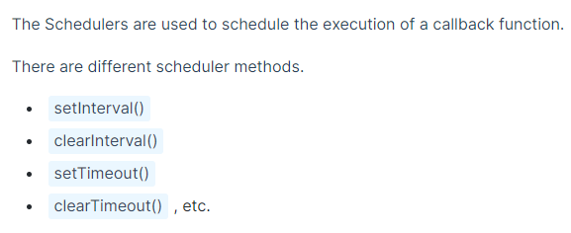

Callback function ni at regular intervals or events jariginapudu e schedulers method use chesi execute cheyachu

The above 4 methods of schedulers

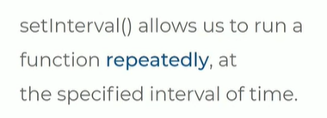

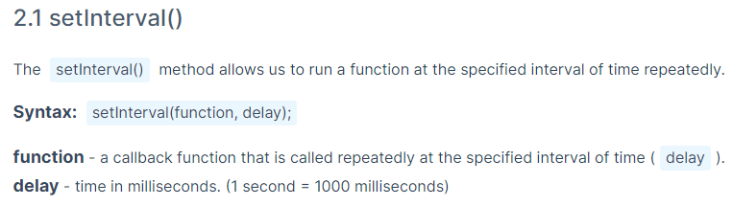

Callback fuction = oka fun ni inkoka fun ki argument laga pass chesthe Danni callback function antam

Syntax:

1st argument = callback function

2nd argument = delay = prathi milliseconds ki fun execution

Example:

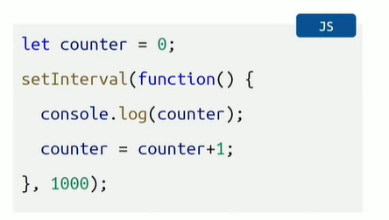

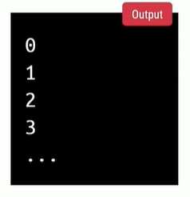

* Counter ane variable ki value initially 0
* Prathi 1 sec ki counter variable lo unna value+ 1 ki increment avvali
* Setinterval lo oka function undi based on time we need to repeat the function
* 1000 milli seconds means 1 second
* Increment prathi one sec ki fun execite avthundi
* Output lo prathi one sec ki counter variables print avthayi

Setinterval lo time interval lo infinite time run avthundi denni stop cheyadaniki clearinterval ane method use chestham

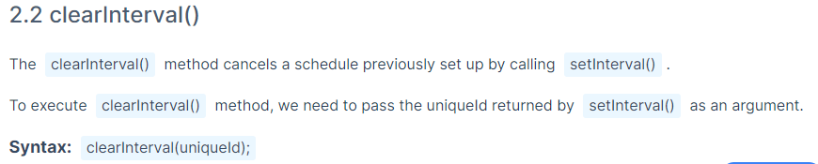

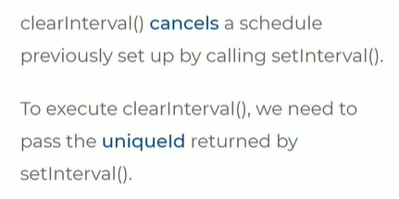

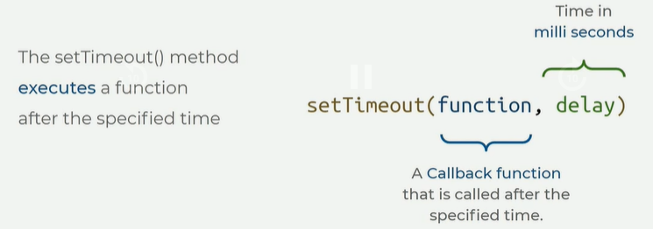

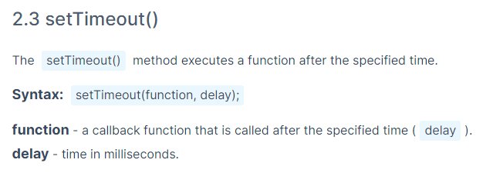

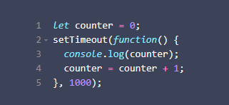

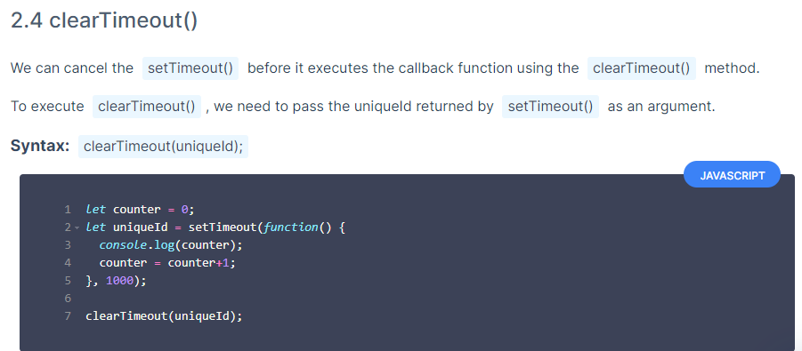

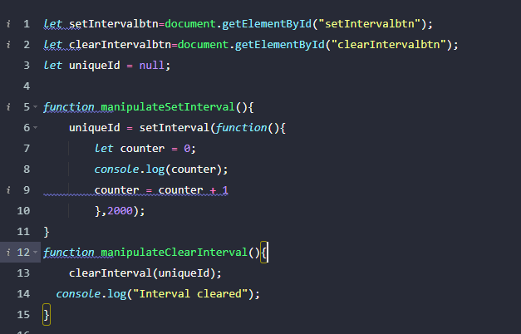

clearInterval ki uniqueID argument icham after creating variable with valuenull, and setintreval ki variable fix chesam

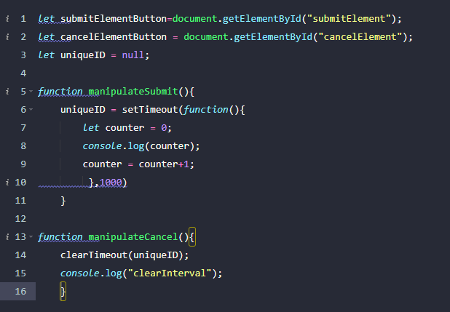

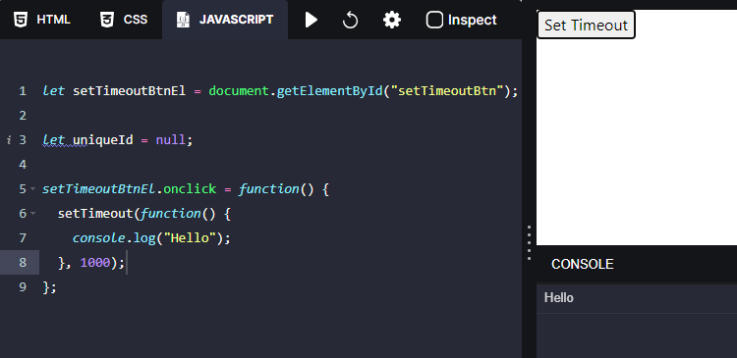

**EVENT LISTENERS AND MORE EVENTS**

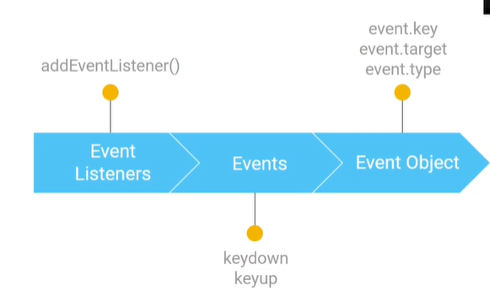

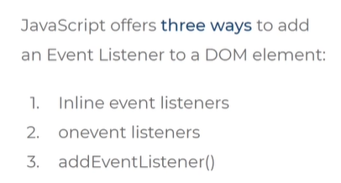

3 ways lo DOM elements ki event listeners add cheyachu

Inline , onevent, addEventListener

**INLINE EVENT LISTENERS:**

* Html lo onclick event create chesi
* Js lo function call chesthe inline

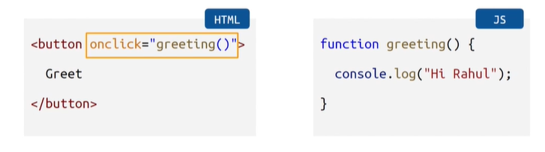

**ON EVENT LISTENERS:**

* Button create chesi id ivvu
* Get element by id ani oka unique variable name ivvu
* Create chesina unique variable ki onClick event ivvu
* Function expression rayi

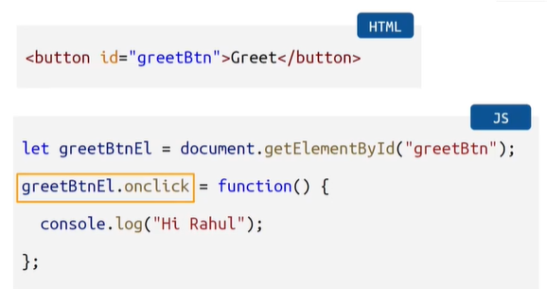

**ADD EVENT LISTNER:**

Modern approach

Mostly followed this rule

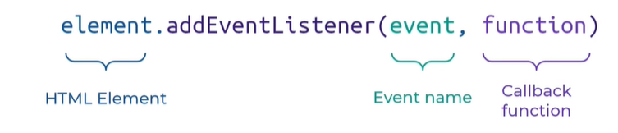

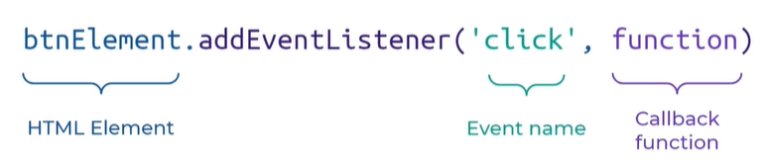

1st arg = event name = onClick just click on undadu

2nd arg = callback function = execute avvalsina function

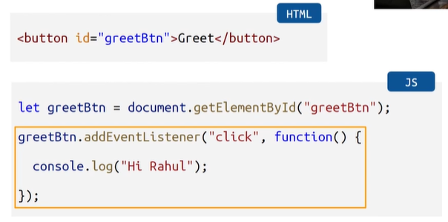

* Id ichamu html lo button ki
* Get element by id annamu
* Variable name ichamu
* Variable_name.add event listener ane method ichamu argument lo 1st di click taravtha function

**MORE EVENTS:**

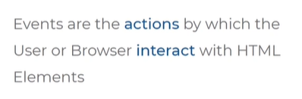

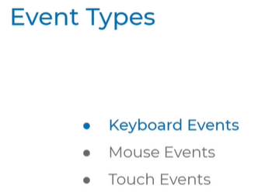

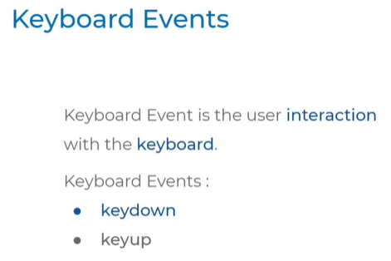

Press chesthe = keydown

Press chesina Danni release cheyadam = keyup

**Keydown:**

* Html elememt dot
* Add event listener ane method lo arguments pass cheyali
* 1st arg = keydown
* 2nd arg call back fnction

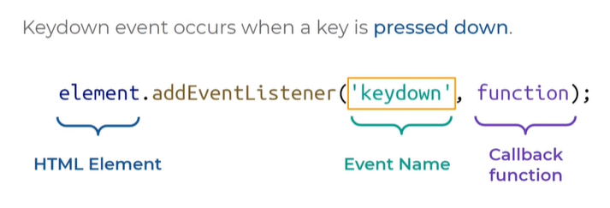

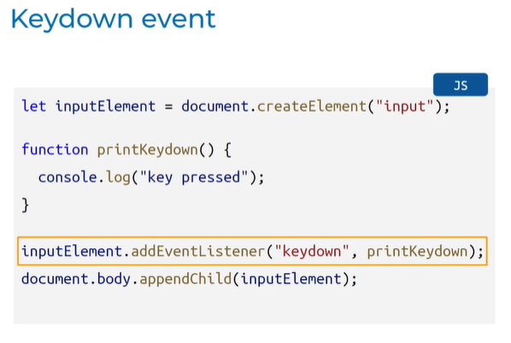

* Input ane html element create cheyali
* Add event listener ane method lo keyword argument pettam
* Function declarartion chesam
* Body ki add chesam
* Edi ayina key press chesthe ala vasthadi console lo

**How to know which Key is pressed?**



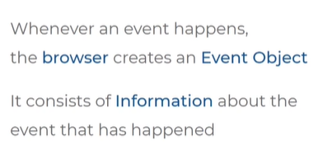

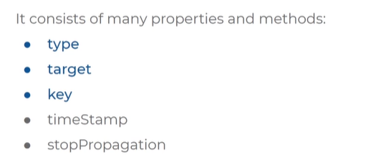

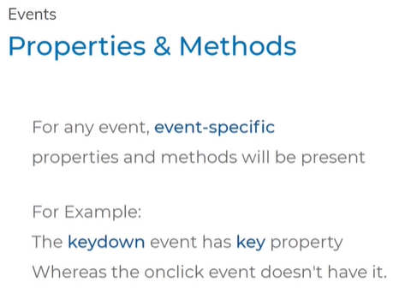

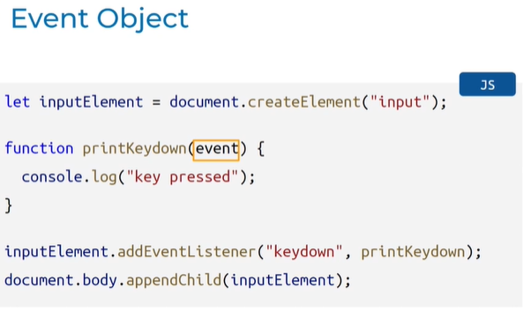



Type ante ey type of event anedi vasthundi



Target ante ey html element meda event anedi jarigindi input ane element jaruguthudi so ade vasthundi



Ey key press ayindo chepthundi

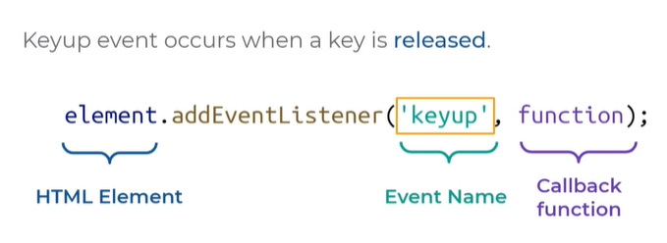

**HTTP (HYPERTEXT TRANSFER PROTOCOL)**

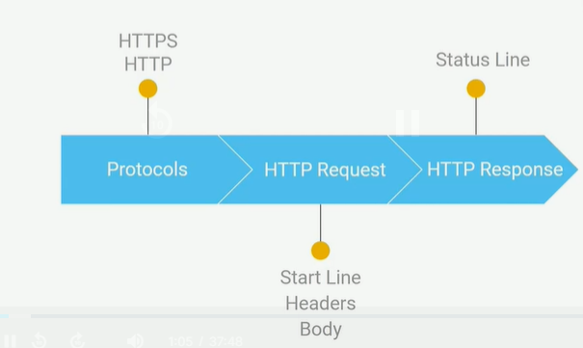



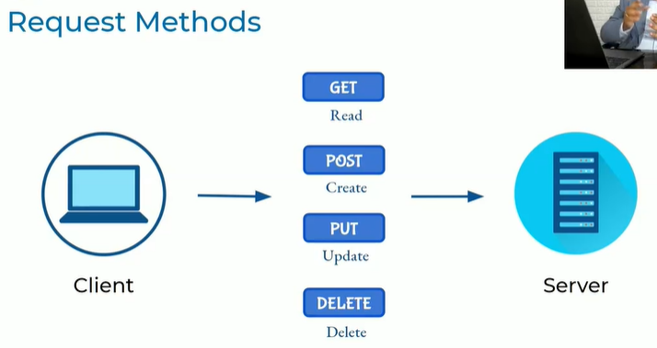

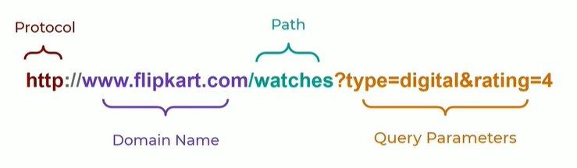



**HTTP REQUEST USING JS**

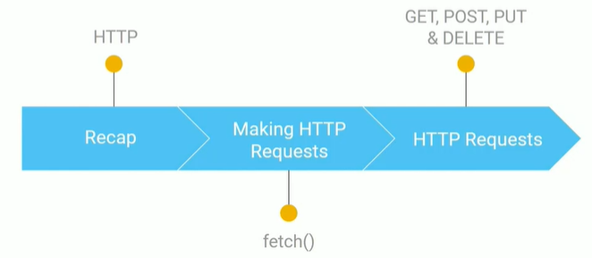

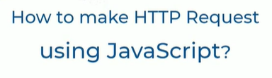

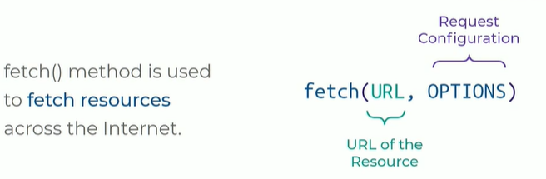

Fetch ane method use chesi internet lo resources ni access cheyachu

* 1st arg = url to locate
* 2nd arg = options lo values pedatham
* JS lo fetch ane method undhi
* E method ni sue chesi HTTP req and response ni chudachu
* Fetch ane web lo resources ni get cheyali
* Fetch of ane method ni use cheyali
* 1st arg = url
* 2nd arg = options lo [headers, body, http req method]

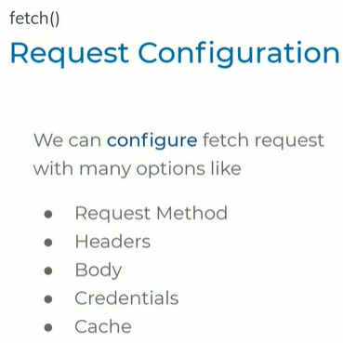

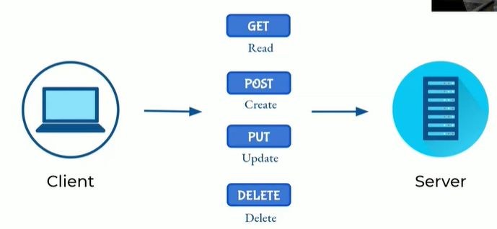

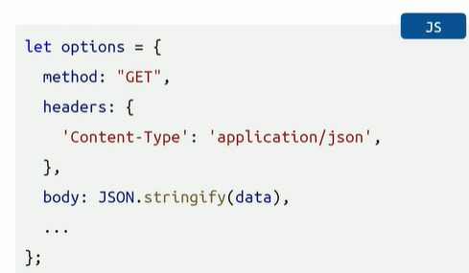

* Options = oka object e object lo req configuration pettam
* Fetc ane method ki url and option properties pampistham
* Apudu req server ki velthundi
* Method ane property/key ki value get
* http method get
* headers ..
* body..

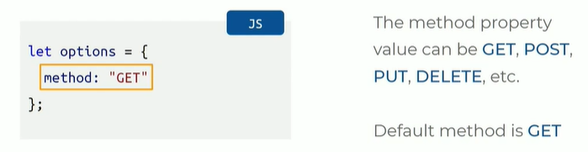

* HTTP request methods : get, post, put, delete method
* Options ani oka object create chesam daniki key method ichamu and value get pettam

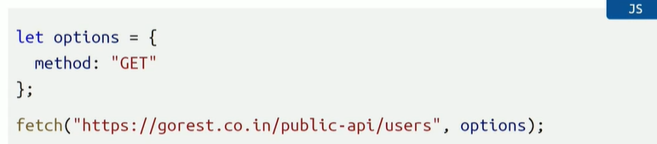

* Fetch ane method use chesthunnam danilo url undi to locate
* https = secured protocol
* client nunchi server pampe info chudaleru
* domain name= e server ki req vellali
* users ane resources ni we are accessing

**WIKIPEDIA SEARCH APPLICATION**

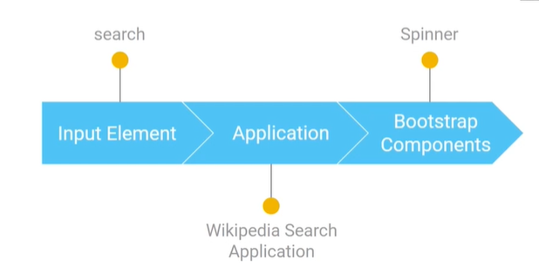

Application:

Inputbar

Static part code available – html,css

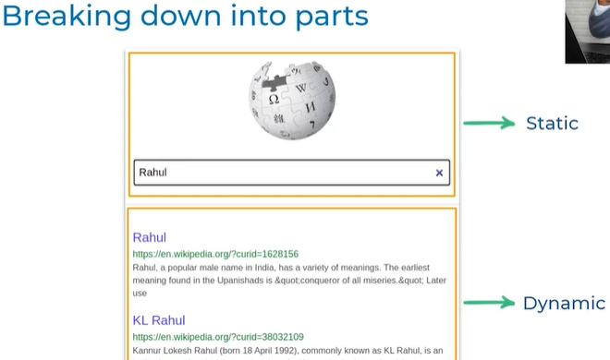

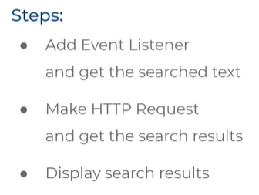

STEP 1

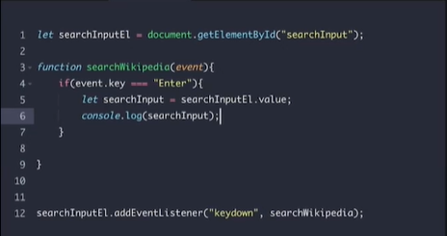

* Searchinput id ki searchinputEl ani variable ni add chesam
* Searchinput ki value get chesamu oka variable name ichamu
* Add event listener lo keydown ane property ichamu, function define chesam
* Function call cheyi,If condition pettu
* Console lo kanipisthundi

**FORMS**

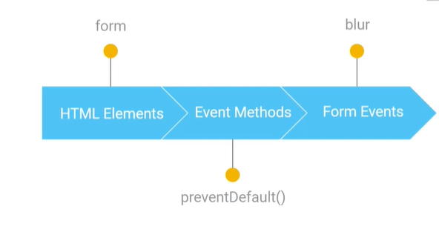

Default behavior after submitting:

preventDefault() method

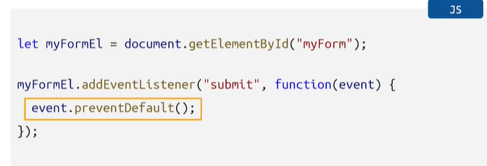

Form lo id getelement byid chesi variable name ichamu

Add event listener lo submit , function method ad chesam

**JS ESSENTIALS**

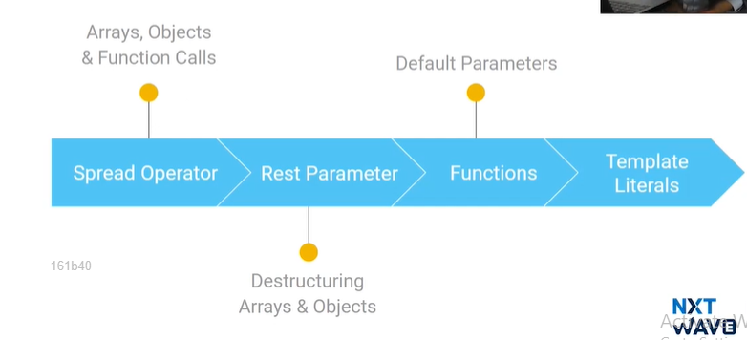**SPREAD OPERATOR:**

* Iterable items meda spread avvadaniki use chestham
* Eg: Array, dictionaries
* By using Spread operator we can unpack items
* Eg: here we have variable myArray and we have elements 1,2,3
* Prathi element ni manam unpack cheyadaniki 3 dots pettesi variable name pedithe separate chesi rasinattu

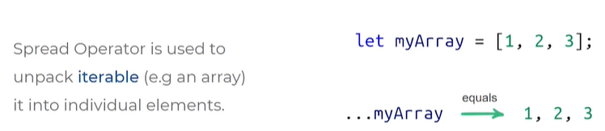

Example:

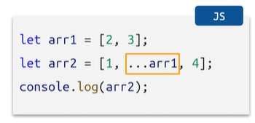

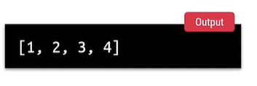

…arr1 unpacked 2,3 elements which comes in output arr2

This is spread operator …arr1

Creating a copy

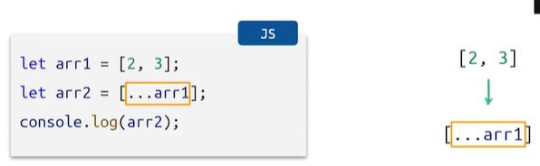

Concatenate 2 arrays

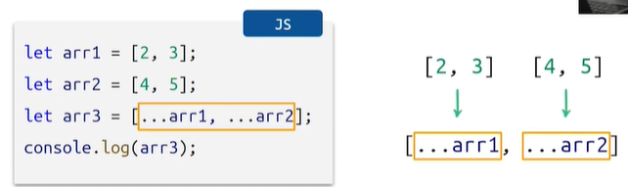

Unpack ayyi elements la add avthayi

SPREAD OPERATOR WITH OBJECTS

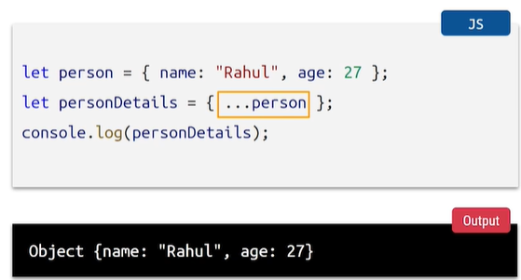

PersonDetails is a copy of person ane object

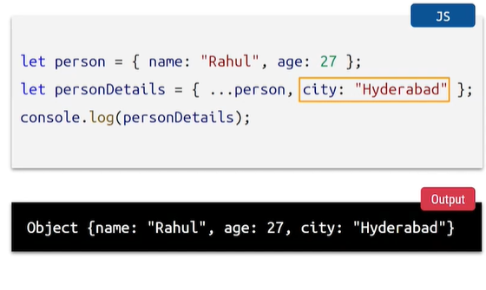

* …person lo unna items/properties unpack avthayi
* City ane properties add chesam key city and value Hyderabad

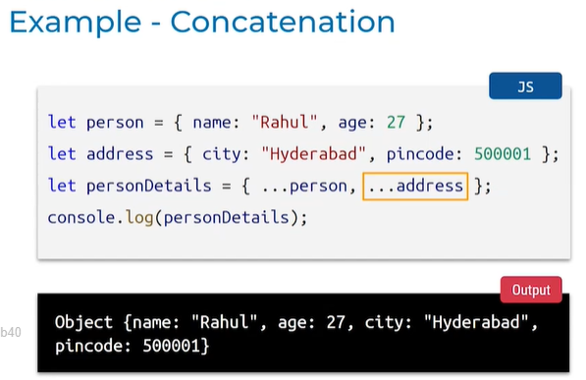

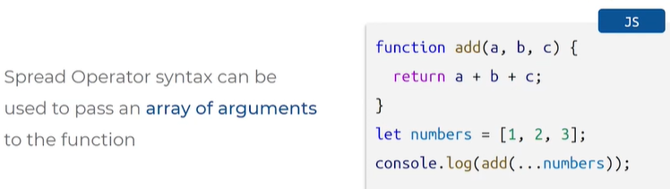

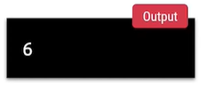

* Add ane function undhi daniki arguments a,b,c
* A+b+c return chesthundi
* Pass chese numbers array lo unnayi 1,2,3
* E values ni add ane function ki a=1 b=2 c= 3
* Use spread operator to unpack that array becomes eleements 1,2,3

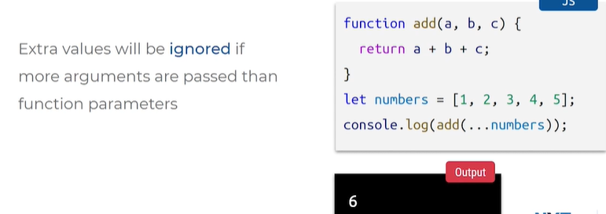

* Extra values 4,5 arguments levu kabatti ignore avthayi

**REST PARAMETER**

Spread operator tho manam unpacking chusam array, object, function examples tho

Rest parameter tho multiple values ni packing cheyachu

Example:

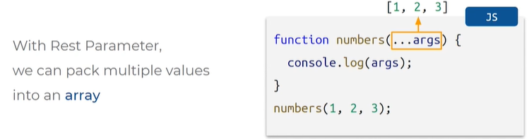

* In this example
* Function call chesam numbers
* Arguments = …args
* Args call chesthunnam
* Oka array kindha pack ayyi values assign avthayi

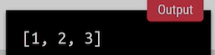

Example:

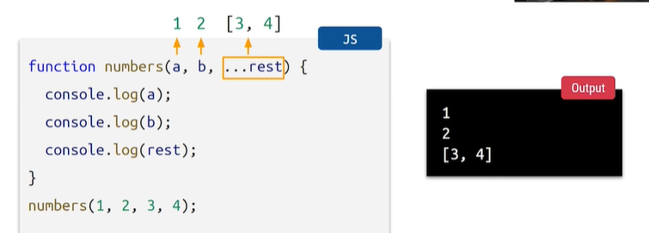

* Function numbers
* Arg = a,b , rest
* Individual ga print chethunnam
* Numbers Func call chesam rest ane arg ki assign ayyela rasam code

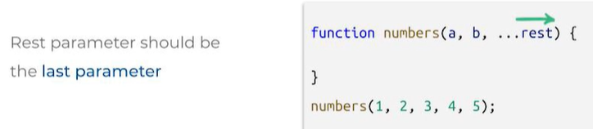

* Syntax error vasthundi first lo pedithe
* Always last lone pettali rest ane argument

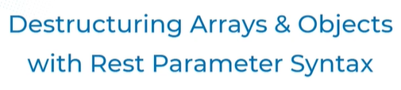

Unpacking = destructing

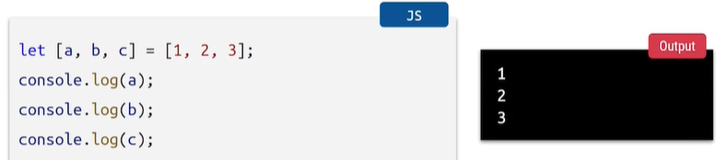

Let array lo variables pettam values assign chesam

A ane variable loki 1 b lo 2 c lo 3 vasthayi

Rest parameter ekkada ela use cheyali ante

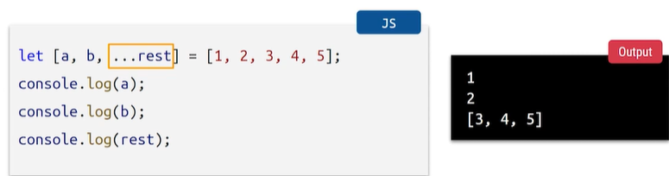

Last lo rest variable assign cheyali

Migatha values assign avthayi

Epudu objects:



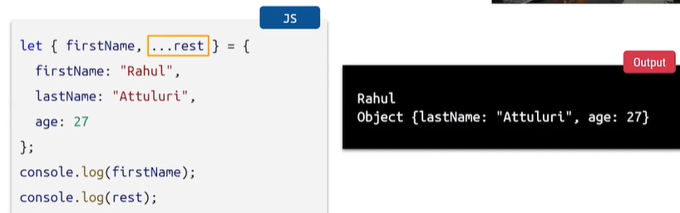

Rest parameter pettam

Key and values define chesam

Migilina properties anni kuda rest ane object key ki pampisthunnam



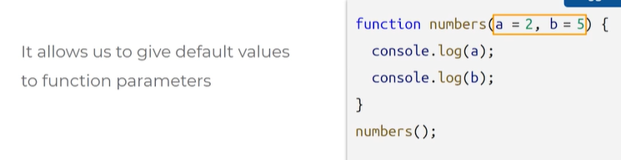

Function lo default ga arg ki a= 2 b= 5

Numbers function call chesinapudu values em ivvaledu

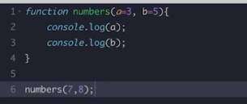

Numbers ela define chesthe console lo 7,8 vasthadi default ga pettina 3,5 ravu

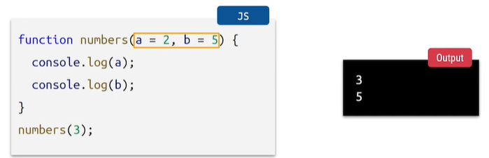



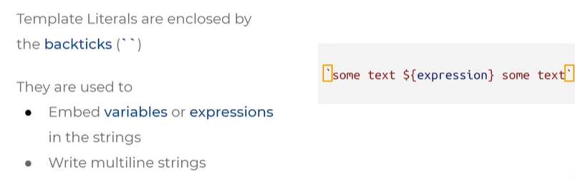

Backticks madhyalo series of characters ni pedithe template literal or template string antam

Can use for multi line strings

Example:

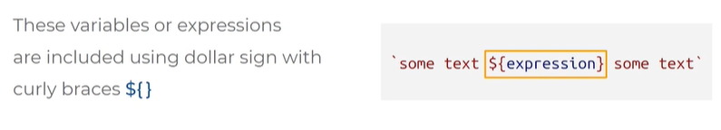

Can keep variable or expression like 2+3

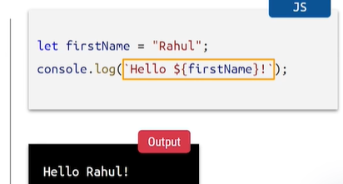

Backticks

Dollar

Flower braces

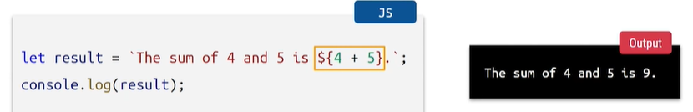

Object property acces in template literal

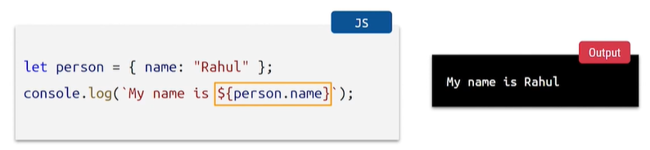

Multi line strings access

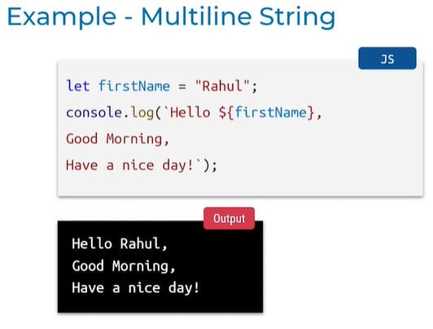

**MORE MODREN JS CONCEPTS**

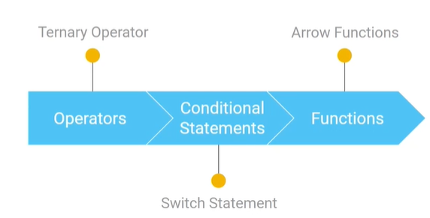



* To replace if else statements
* Condition true exp1 executes
* Condition false exp2 executes

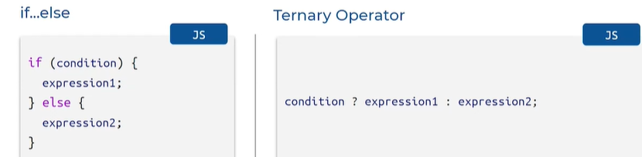

EXAMPLE:

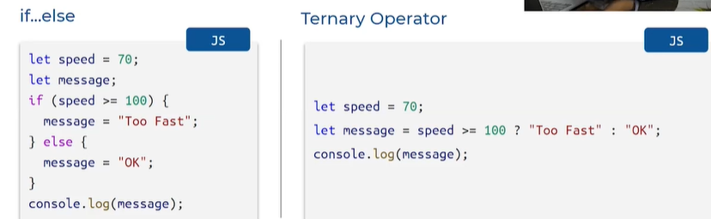

* Speed 100 or ekkuva ayithe too fast ani print cheyali lekapothe ok ani print cheyali
* Speed ekkada 70 condition false so output is ok

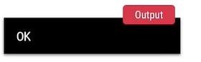

* Speed for suppose 170 condition true so output is too fast

Example: 2 find min value

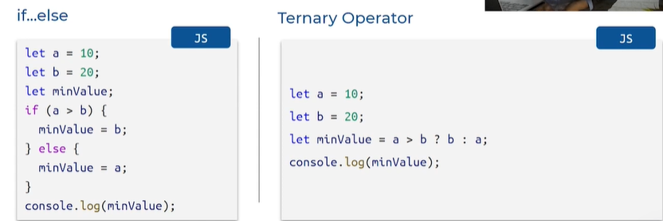

A= 10 b = 20 we have 2 variables a and b

We have to identify min value so we created a variable for this

A value b kante ekkuva unte minimum b vasthundi thakkuva ayithe a value print avthundi



If,elif,else statement decision making unna cases lo switch ane statement use chesthe concise cheyachu code ni

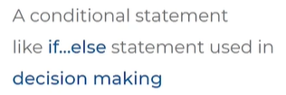

**SYNTAX:**

Switch of lo exp pedthaam deni value possible values tho evaluate chestham with name case

Break ;

Case value 2 ki equal ayithe edi execue avvali

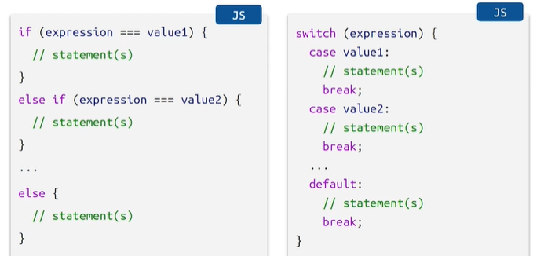

**EXAMPLE:**

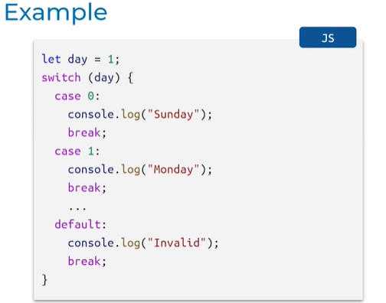

Day ekkada one

Day 0 ayithe Sunday

Day 1 ayithe Monday

Day value proper ga lekapothe invalid ani print avthundi

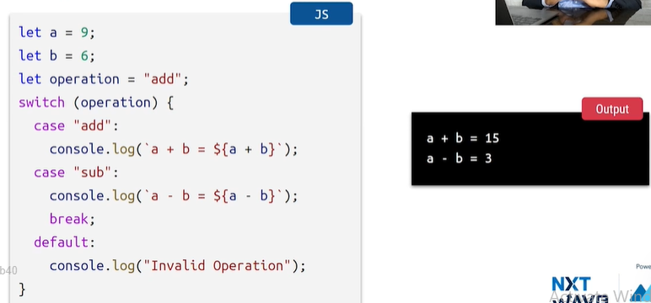

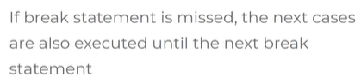



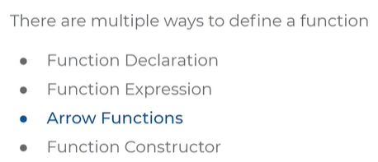

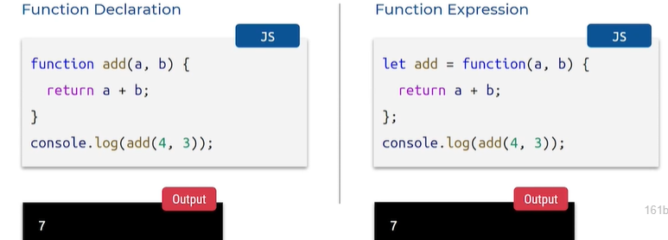

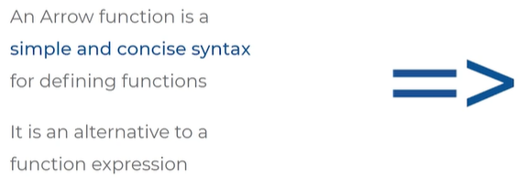

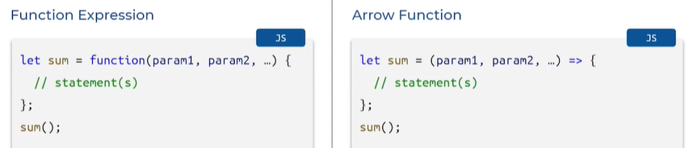

Function keyword pettakunda direct ga arguments pedatham

taravtha arrow symbol petti function expression rasthunnam

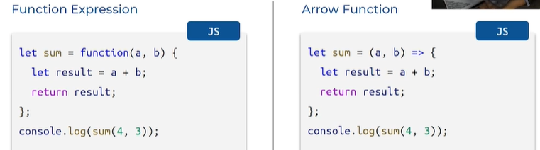

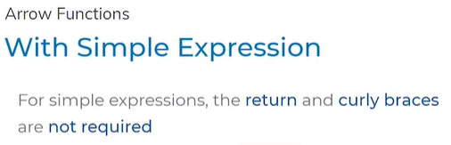

Simple expression lo curly braces return thisesamu

Flower braces thiseyali

Return unte adi kuda tiseyali

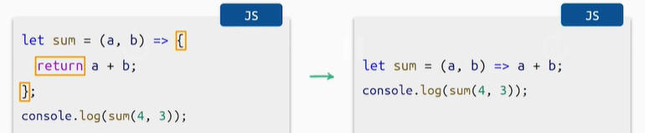

Inko example edi

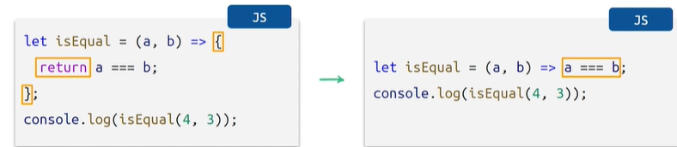

**Arrow Function with one parameter : remove round braces**

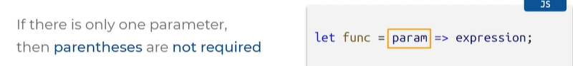

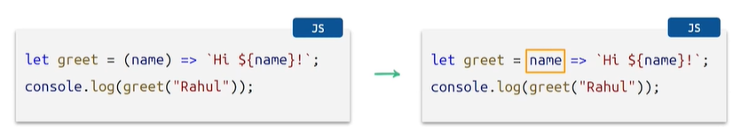

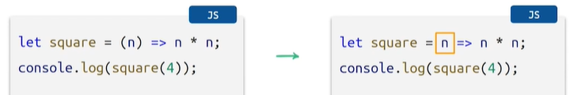



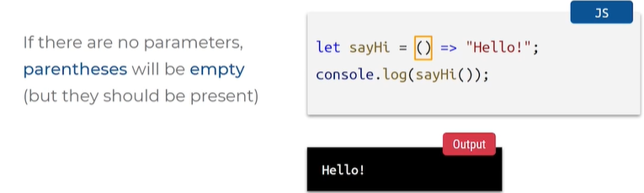



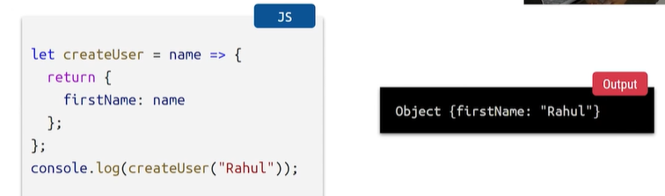

Flower braces thiseyi

Return theseyi

Undefined ani vasthundi

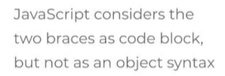

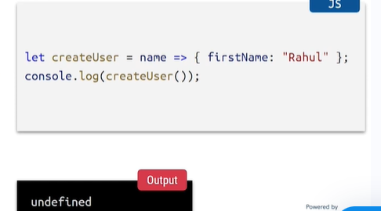

Keep round braces to avoid the above problem

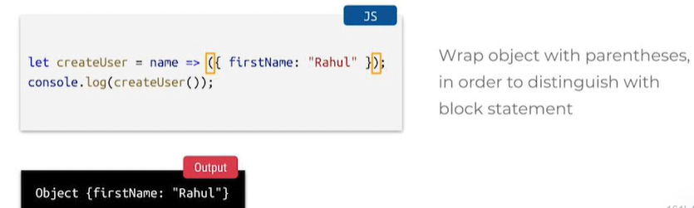



MORE OBJECTS:

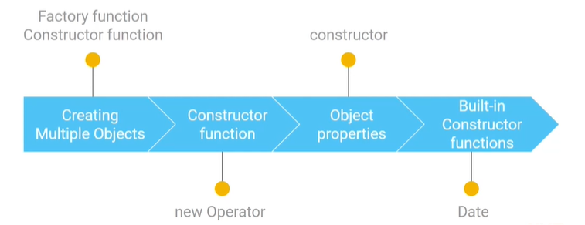



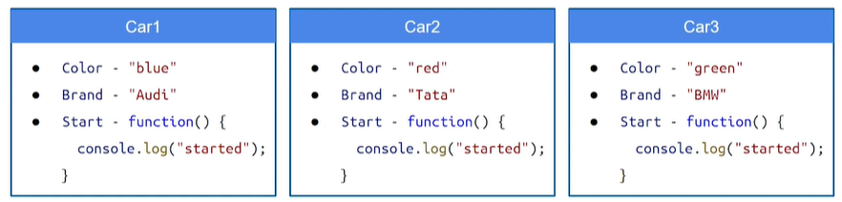

We have multiple methods to create objects

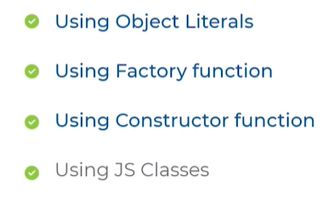



* Car1 anedi oka object, 2 anedi oka object, 3 anedi oka object
* Flower braces
* attribute and value
* Function pedatham

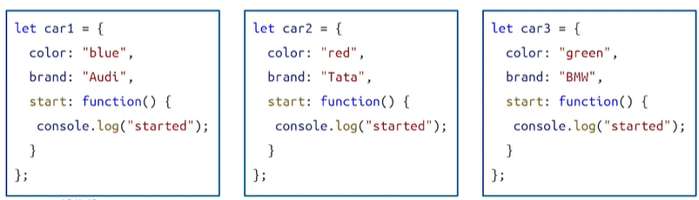



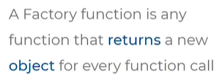

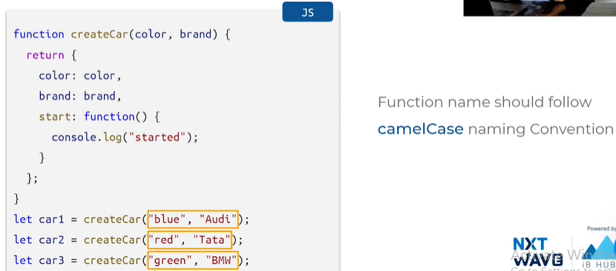

* Arguments color , brands
* Return lo key and value arguments ey pass chesamu
* Start ane daniki function rasamu
* Camelcase convention
* Let car1 = created object ,car2,car3

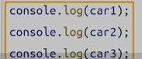

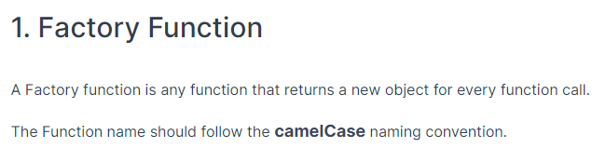

USING SHORT HAND NOTATION

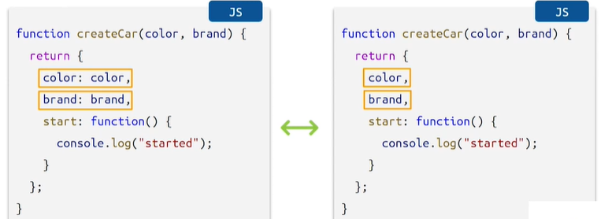

Arguments name returning objects lo unna keys should be same

Start function ela kuda rayachu

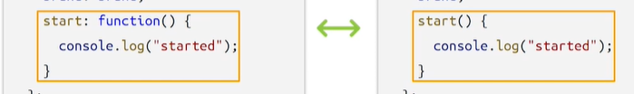



* Another method of creating multiple objects
* It is a normal function which is similar to factory function
* Arguments ni Call chesinapudu kotha objects ni return chetshundi
* New ane operation use chesi call chestham with arguments
* Return aye response object ni instaces antamu

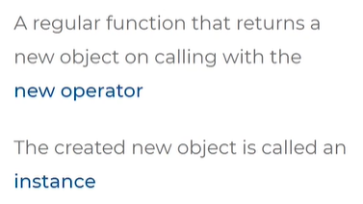

Syntax: Pascal naming convention

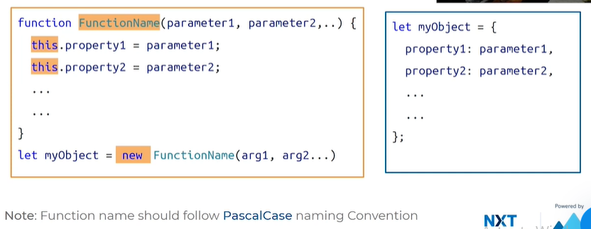function name pascal name convention ni follow avthundi fist letter capital next letter kuda capital ey

properties ki evi ayithe values set cheyali avi arguments ga pass chestham function name taravtha

property ni set cheyadaniki this use chestham

this.property = property value

new and call constructor function and pass values

similar to object literals

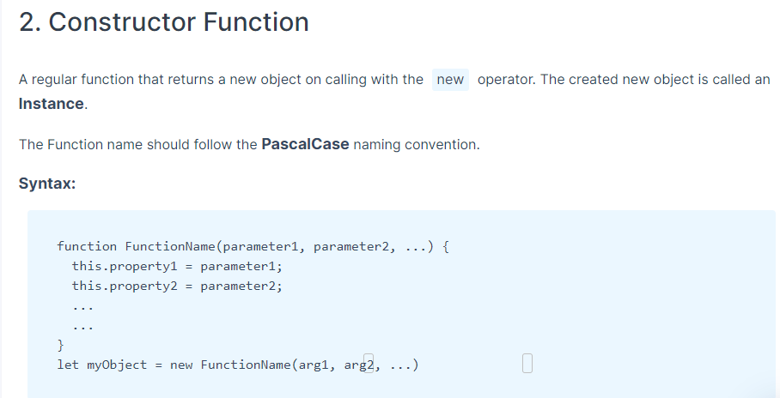

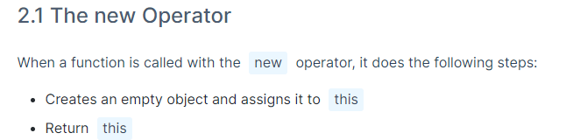

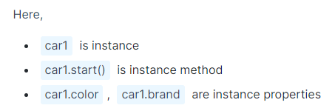

EXAMPLE:

Right: object literals

Left: Constructor function

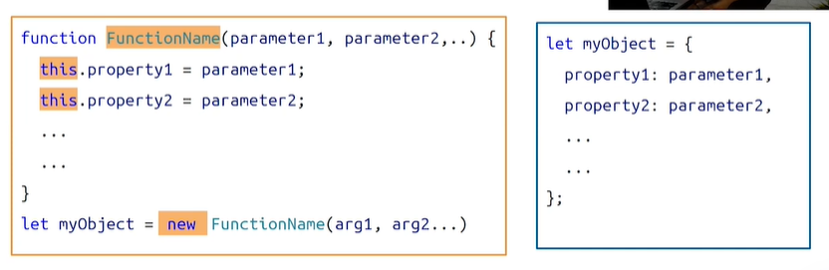

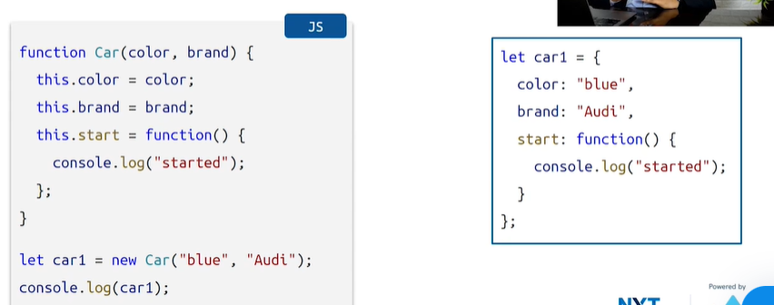

new ani fun call chesaka return avthundi

this ane object ki dot notation tho assign chesam

constructor function kabatti this dot ani properties assign chestham

new ani function peru pettesi pani color ane property ki kindha values pettali

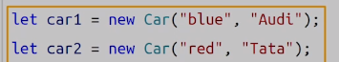

Ela diff variable names tho multiple objects ni create cheyachu

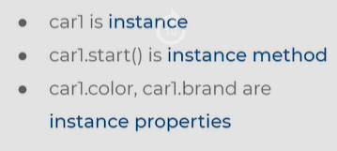

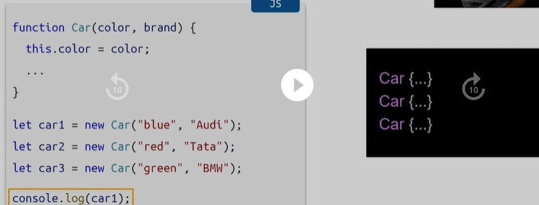

Ela console.log chesthe objects anevi print avthayi

DIFFERNCE:

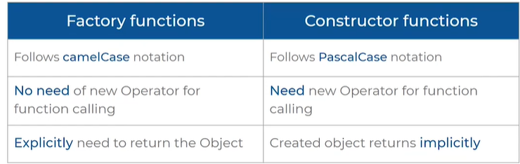

JS lo functions are objects

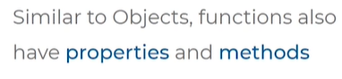

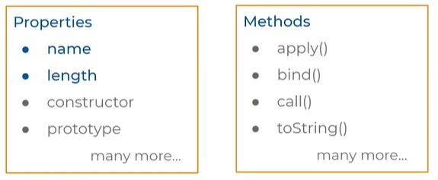

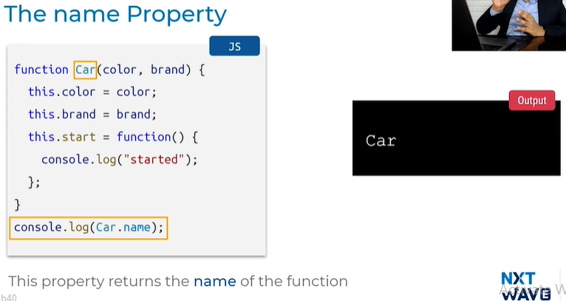

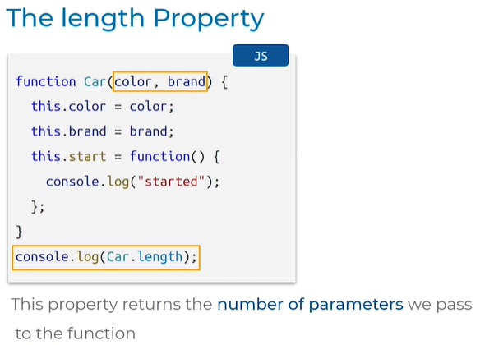

Car.length = returns length = 2 no.of arguments enni pass chesthunnamo anni vasthayi

Check type of car output is function

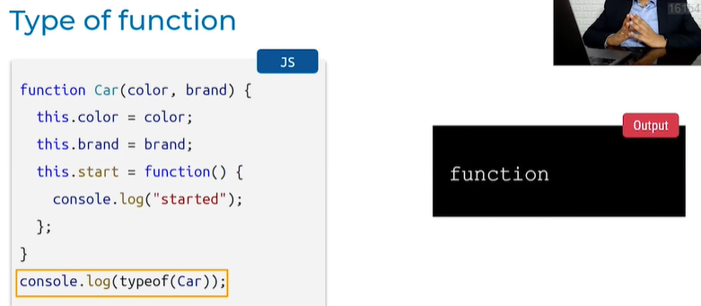

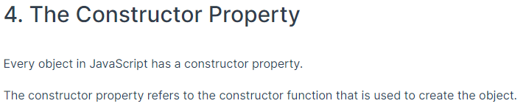

Js lo prathi object ki constructor ane property untadi

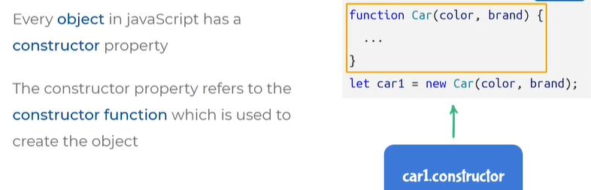

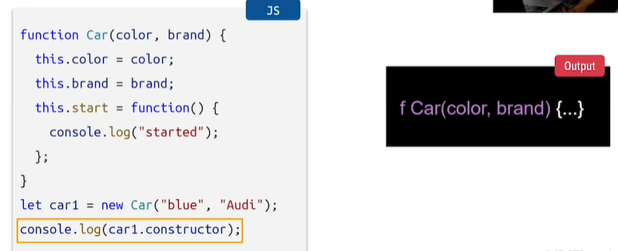

Let car1 = new car

Car1 ane instance vasthundi

Ah instance ki car1.constructor ani property call chesthe

Ey constructor function ni use cheskoni e object create ayindo ah function manaki output lo print avthundi

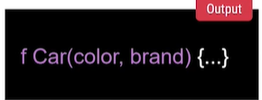



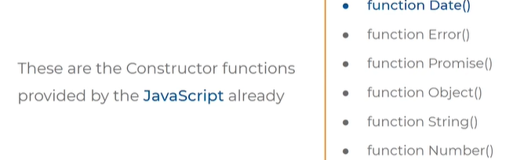

Date, error…. These are constructor functions



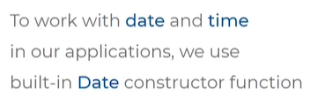

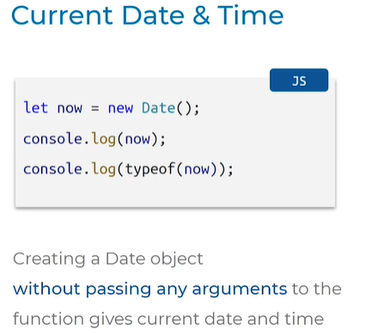

Variable pettesi new ani constructor func ni call cheyali

Arg em pass cheyatledu

Diff prop method set ayyi oka obj ni return chesthundi we call it instance

TypeOf = object

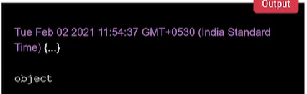

String format= WE CAN GIVE DATE STRING

Multiple types lo ivachu

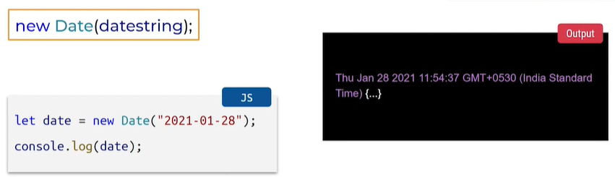

NUMBER FORMAT

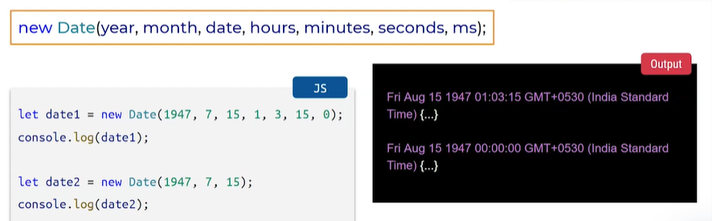

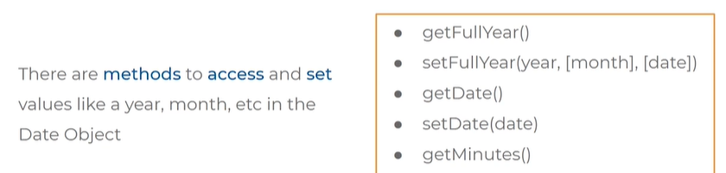

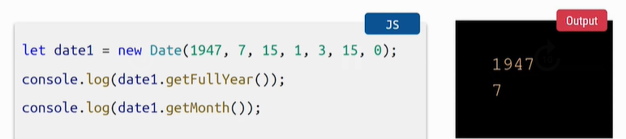

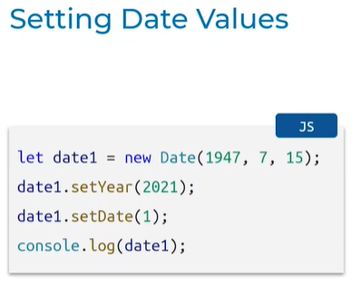

Update chesam year ni 2021 ki

Date ni 1 ki

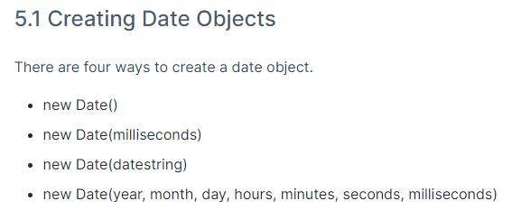

BUILT IN CONSTRUCTOR FUNCTIONS:

Function Date() :

* new Date() = it is a constructor function
* date is a object

**Current date and time**

**New Date (milliseconds)**

**Date string format** = can only pass year and month,mon & day in any manner, short hand format, long hand format, mon can be full or abbreviated, can pass year,mon,day,hrs,min,sec,milliseconds,

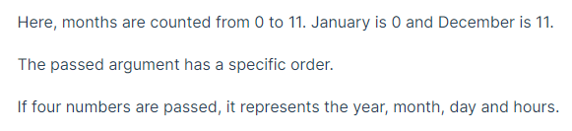

**Date number format**

**Get year**

**Get month**

**Update year and date**

**AUTOCORRECTION IN DATE OBJECT**

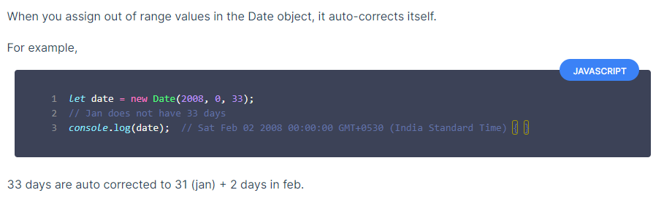

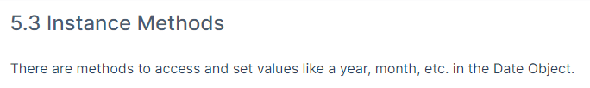

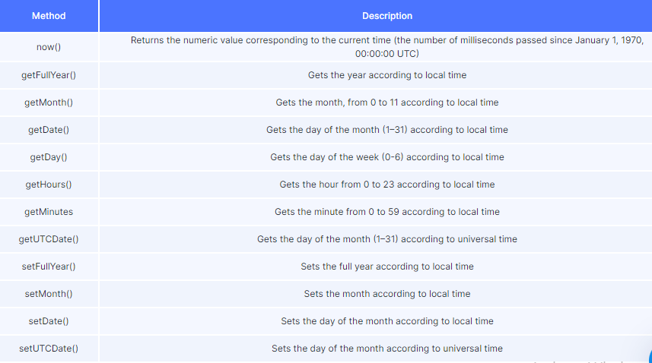

**MORE MODERN JS CONCEPTS**

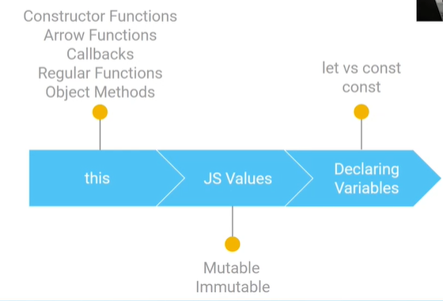



This ane variable lo em value untadi anedi telusukovali ante 3 ways lo untayi

1. object methods lo oka type lo untadi

2. Regular functions lo oka type lo untadi

3. Arrow functions lo oka type lo untadi

First manam e method lo undhi anedi check cheskovali , ekkada undi? object methods lona undha, Regular functions lo undha? Arrow functions lo undha

For suppose if it is in object methods this ane variable denni refer chesthundi anedi chudali

Vice-versa

UNDERSTAND:

This anedi ey method lo undhi chudu first

Object method = e method lo this ane varible ki value ela untadi

Regular functions= e method lo this ane varible ki value ela untadi

Arrow functions= e method lo this ane varible ki value ela untadi

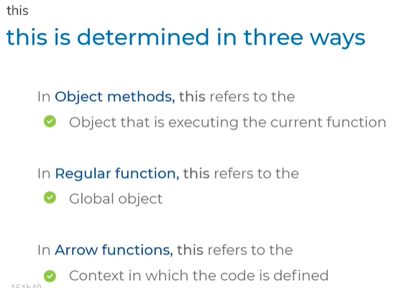

EXAMPLE: OBJECT METHODS

Let car ani oka object ni refer chesthunnaru

Color ane property ki value blue

Brand ane property ki value Audi

Start ane property ki value function or method ni define chesam

Function expression syntax is followed for start property /key

Console.log(this) = e this anedi ekkada undhi , e case lo car ane object lo start ane method / fun lo undhi

Start = is called obj method because, oka obj lo unna method ni obj method antam

Car.start = car ane object lo unna start ane method ni call chesthunnam

Ekkada this anedi car ane object ni refer chesthundhi

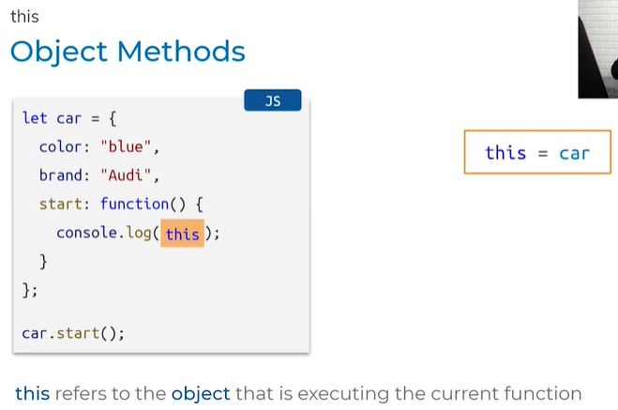

Car ane obj print avthundhi

Ey obj method ni call chesthundo Danni refer chesthundi

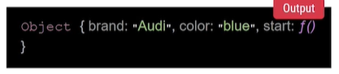

**REGULAR FUNCTION:**

Normal func syntax

Console.log(this) = e this ane variable ey value ni refer chesthundi

Window ane object ni refer chesthundi

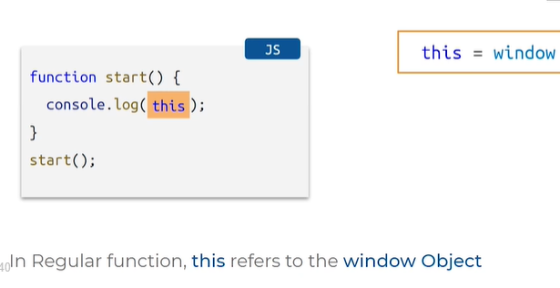

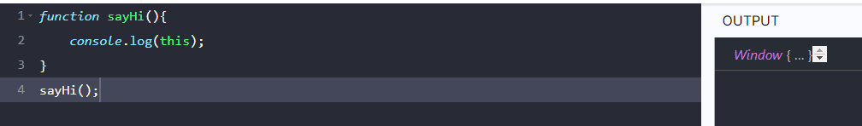

**ARROW FUNCTIONS:**

ARROW FUNCTIONS lo this unte

This ki value anedi deni meda depend avthundi ante 2 methods:

1.ah arrow function anedi epudu define avthundi

2.adi define avthunapudu ah chuttu unna context enti

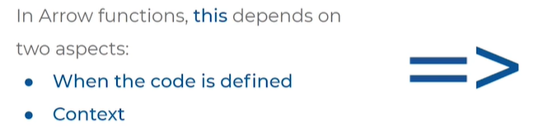

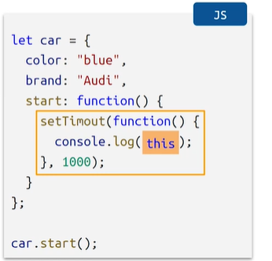

Let car ane object

Color brand property ki values

Start ane function lo settimeout syntax error set time out

There is syntax error we should get syntax error in output but we are not getting any syntax error in the output because function is not executing

Callback fun is not defined

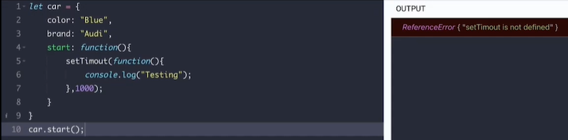

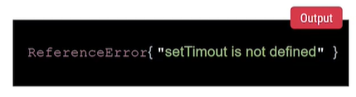

Context:



Start ane function arrow func lo undhi

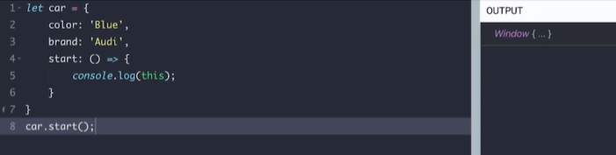

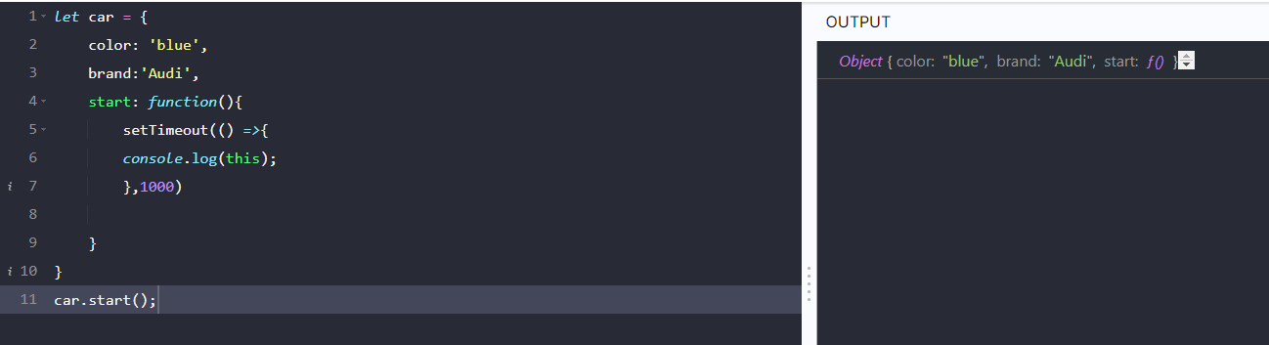

This ane variable arrow function lo undhi

Function is defined when start method is called in car object , func block od code is executed and defines car object

Define aye time unna context enti ante this ane variable referring to object car , car ane object yokka context

**CONSTRUCTOR FUNCTONS:**

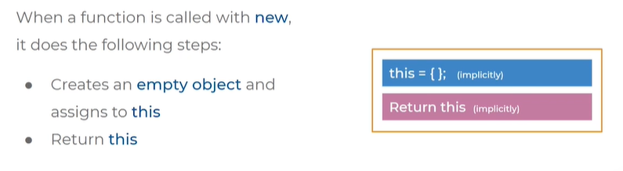

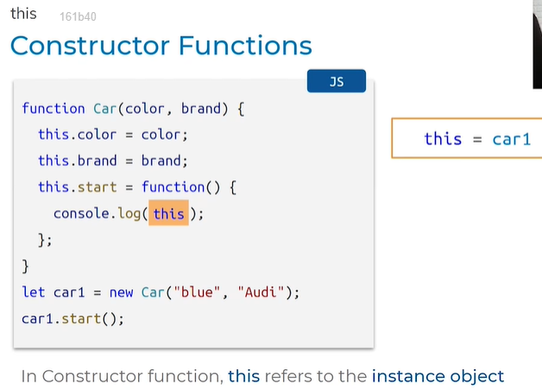

Car object is created property value start fun

New car(passed values)

This.color= obj lo unde properties set avthayi and this.return anedi return avthundi

Arrow fun lo unna this , fun epudu define avthayi dani contex enti



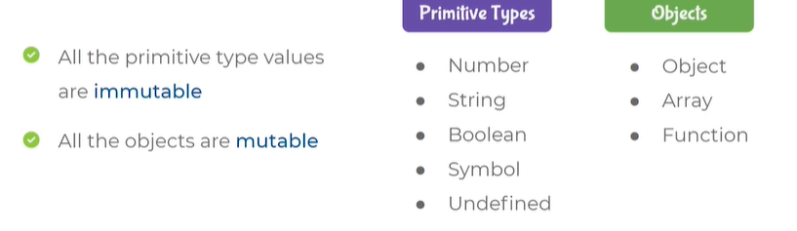

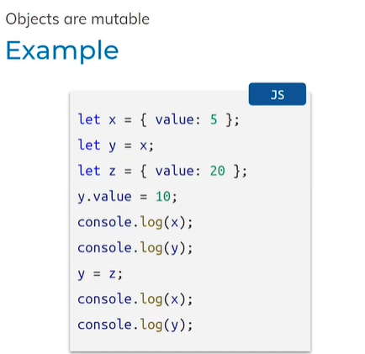

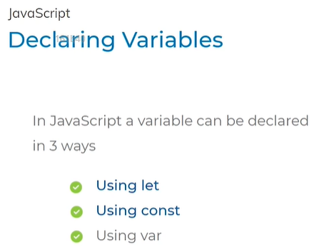

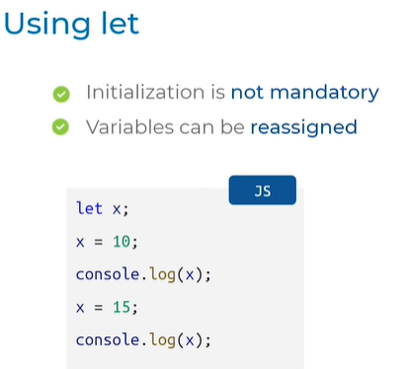

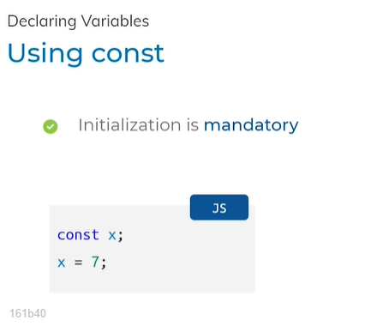

Shows syntax error if not intialised value prior

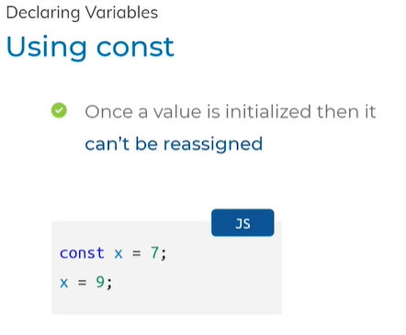

Re-assign chesthe tyoeError vasthundi

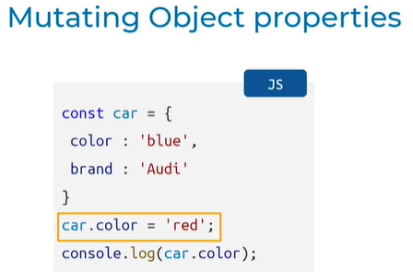

**PROTOTYPES AND CLASSES**

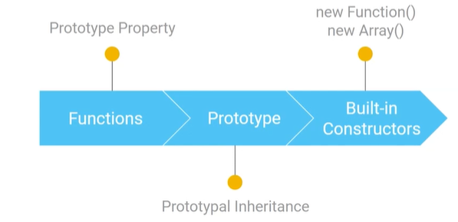

BUILT IN CONSTRUCTORS:

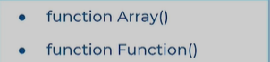



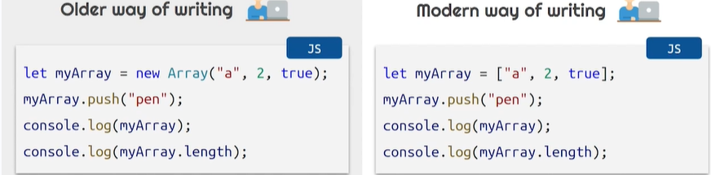

* Creating an array with variable name myArray
* Adding new element with constructor push
* Printed created array and its length

DEFAULT PROPERTIES AND METHODS

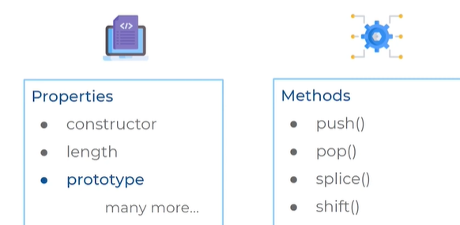

* Prototype property has spl meaning
* It is a shared resources which is shared from multiple instances
* Manam use chese methods anni e prototype ane object lo untayi

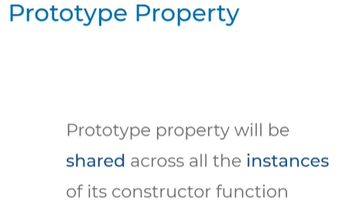

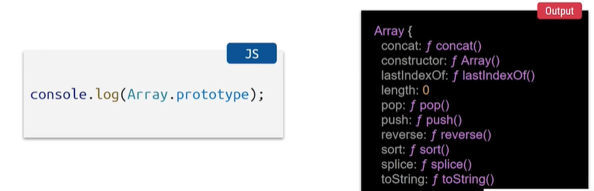

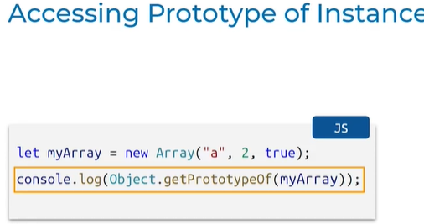

* Let myArray ani new instances create chesi items pettam
* Console.log object lo o capital , get prototype of camel case g small P and o capital
* E array ane constructore function prototype object print avthudi
* Array ki Em methods share ayyi unnayo chudali ante prototype use cheyali

**Accessing prototypes of muntiple instances**

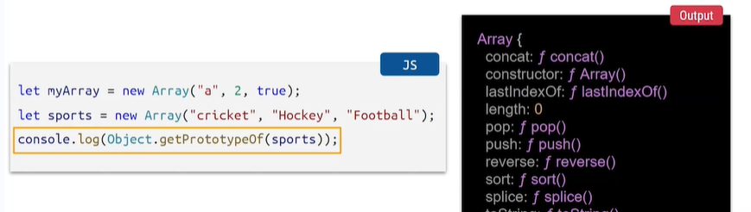

**PROTOTYPAL INHERITANCE:**

* New ane constructor function nunchi call chesthe , constructor function ki prototype untadi kada daniki ref untadi so instaces kuda prototype object annitiki share vathundi kabatti prototype lo unna proeprtues/methods accessed by instances
* This ane object ki empty object assign avthundi
* Constructor fun lo unna prop type obj anitiki share ayiuntadi refer thoti proprerty ob ni nstaces tho copy cheyacu
* Push , pop ,length methods access cheyagalamu

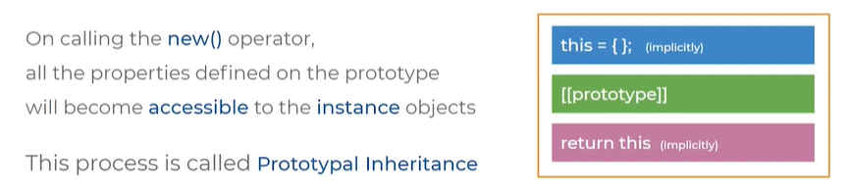



Default properties and methods:

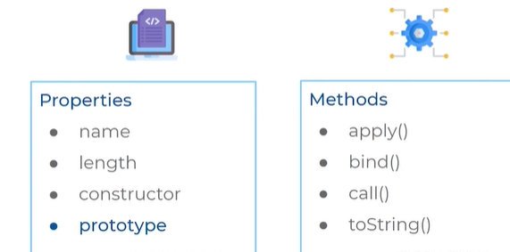

**CREATING A FUNCTION:**

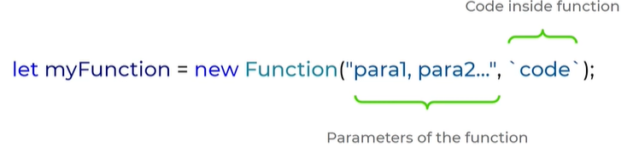

EXAMPLE:

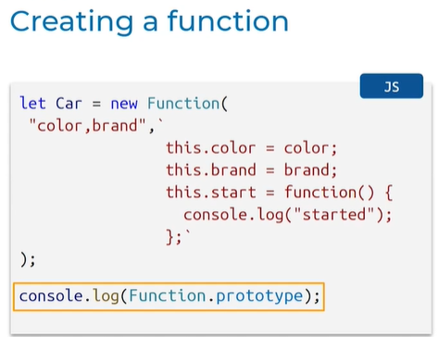

Car fun created by using built in constructor

Color brand attributes

Backticks madhyalo create chesam

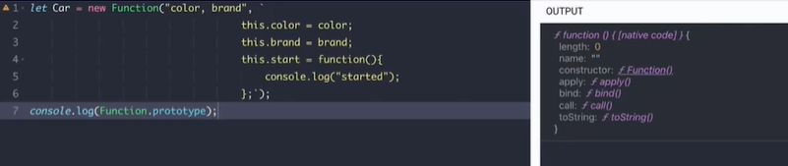

Function prototype lo em unnayo avi print ayyayi

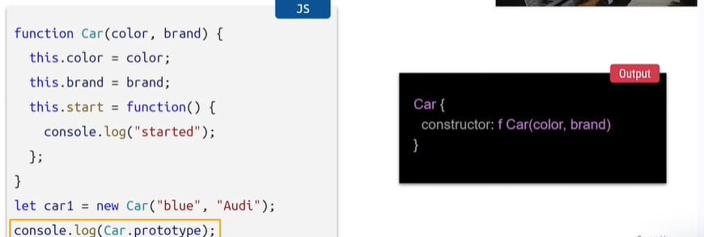

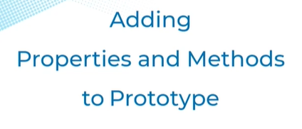

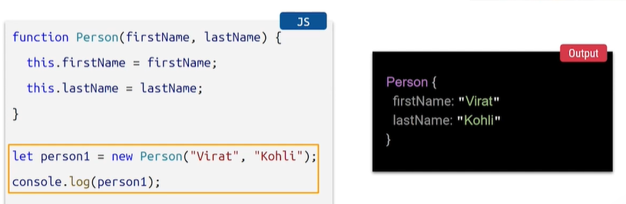

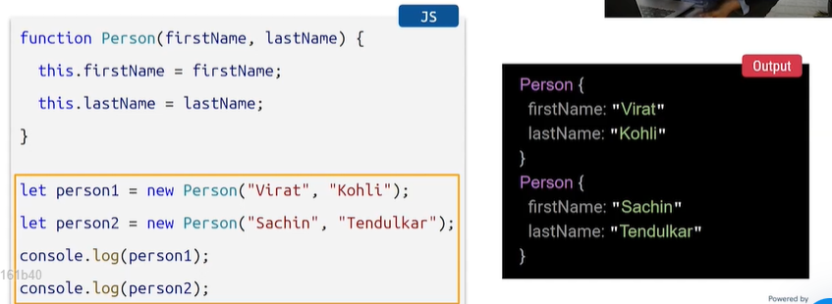

ADDING PROPERTY TO THE PROTOTYPE:

Person.protoype = to access prototype property

Displayfull name ane property addc hesi func expression lo pettam return this.firstname and last name

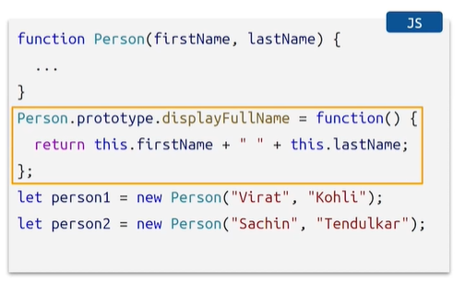

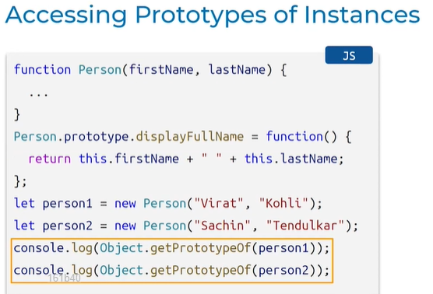

Step:1 object create chesi property access chesam

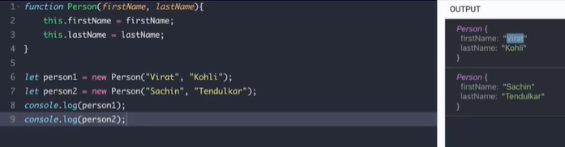

Step 2: kotha property add chesam

Obj.getprototypeof

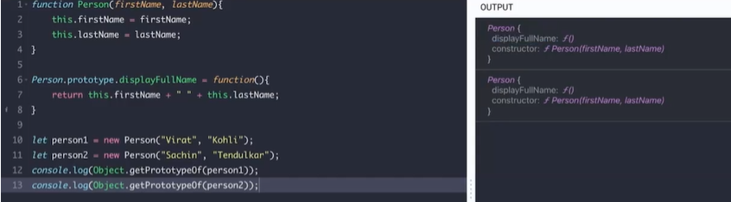

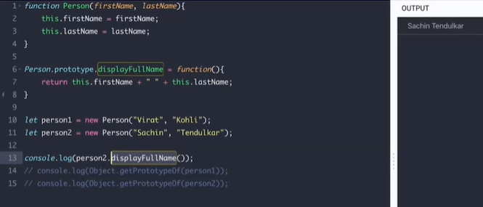

CHECKING SAME FUNCTION OR NOT = TRUE

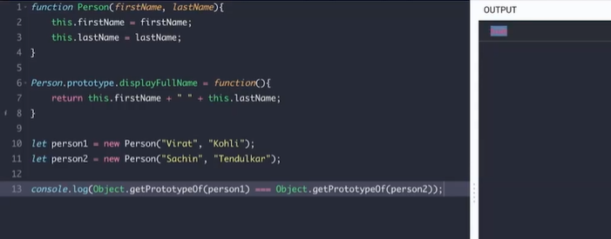

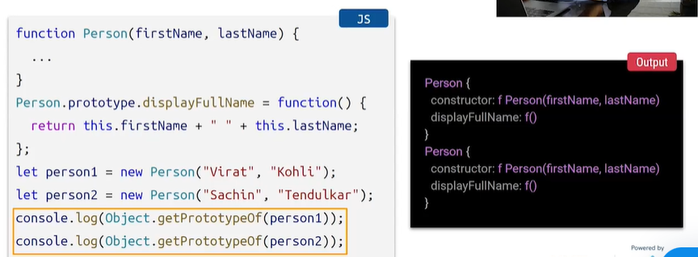

**JS CLASSES**

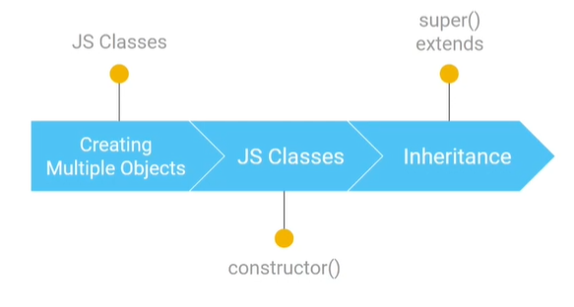

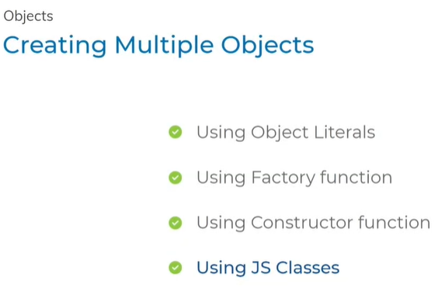

CLASSES: 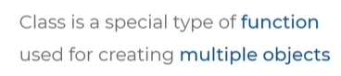

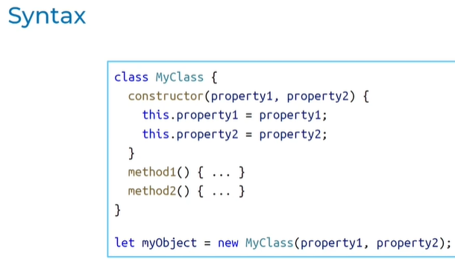

* Class = keyword
* Variable name for class
* Flower braces
* Constructor method loPass arg This. Needed property name = value
* Method name and write as function
* To create objects let variable name = new keyword class name and as arg pass constructor function argments

Similar to __init__ method in python

To create object in class use new keyword and class name with arguments

CONSTRUCTOR METHOD SYNTAX:

* Special method edi
* Person ane class ki manaki em attributes kavalo, constructor ane method tho intialise chestham
* Ekkada constructor lo manam 2 arguments pass chesam, firstname and lastname
* Method lopala this.firstname instance attributes ki values assign chesam
* Displayfullname ane method lo return chesthunnam string concatenation
* New keyword use cheyali values ivvali

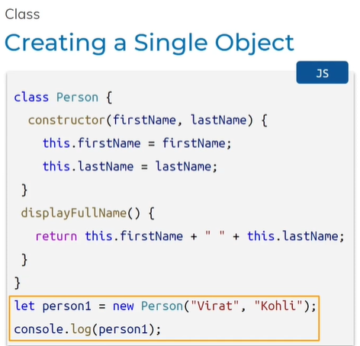

JS CLASSES CREATING MULTIPE OBJECTS SYNTAX

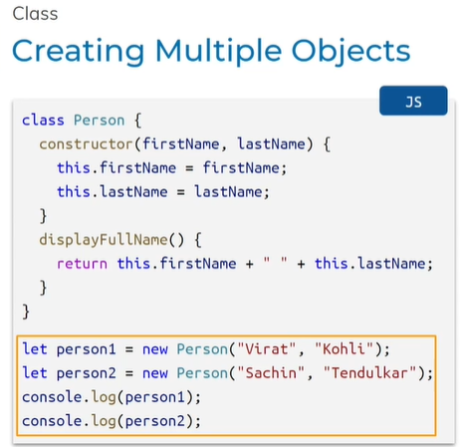



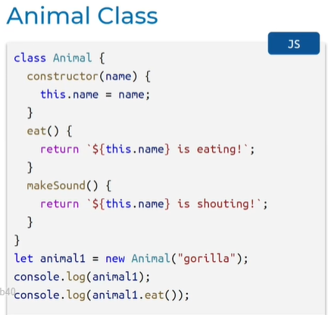

* Class animal created
* Constructor fun argument intialsied name
* 2 methods eat and makesound
* Eat method lo animal name and text eating
* Make sound lo name and shouting
* Animal obj create chesi print chesam
* .eat method ni call chesam

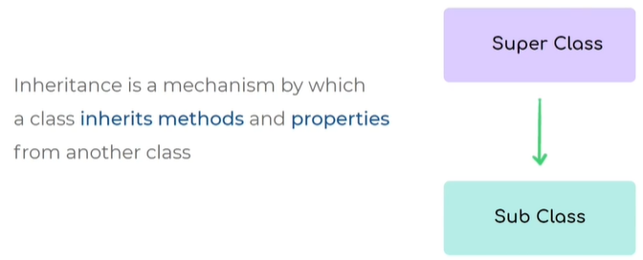

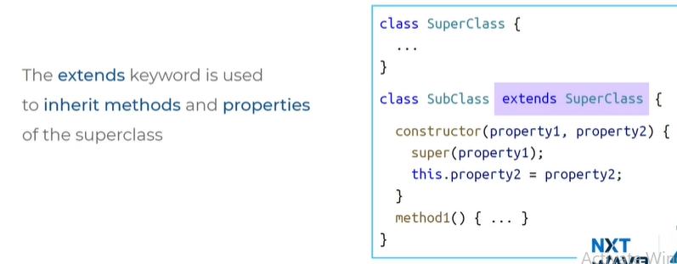

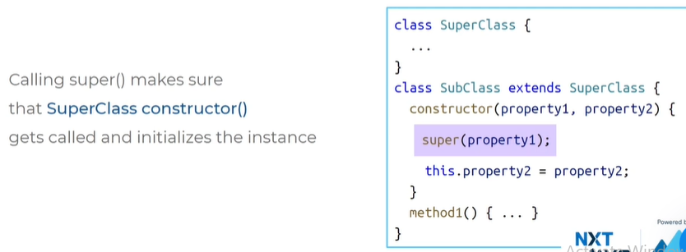

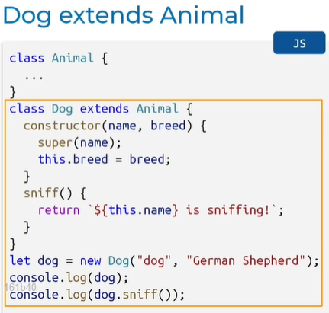

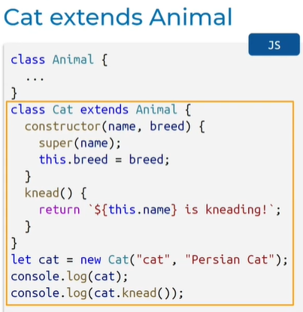

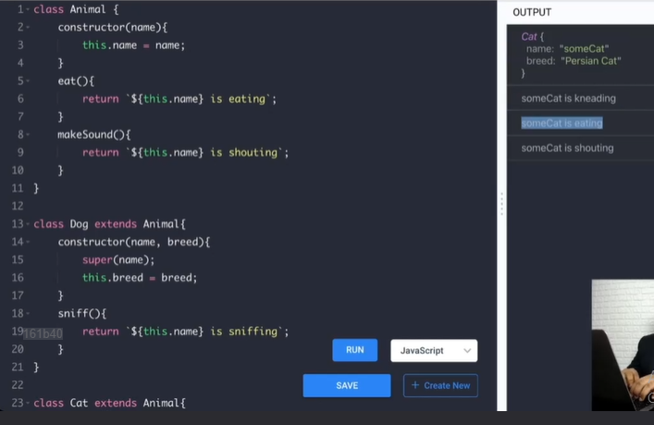

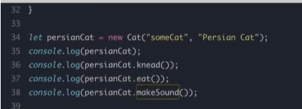

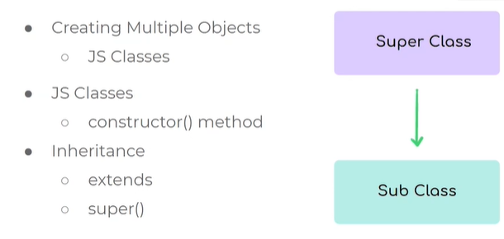

**PROMISES & ARRAY METHODS**

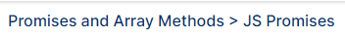

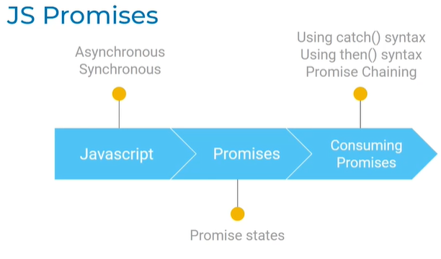

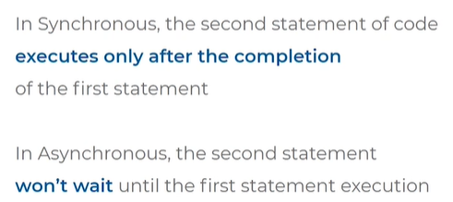

Synchronous:

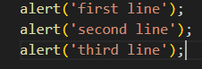

* Goes to next line only after the execution of first line

Asynchronous:

* url Request velli response vachi print avvali
* tarvatha fetching done ani print avvali
* 1st fetch execution complete ayyaka next di print avvali
* Goes to next line only before the execution of first line

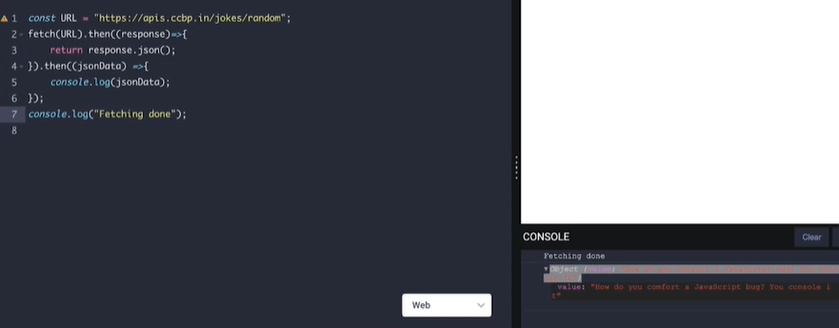

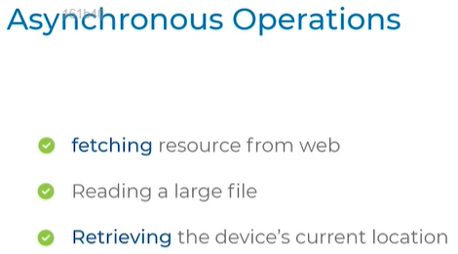

* Time consuming annitiki Asynchronous operations use chestham
* Execution start chesa ekkuva time thiskuntundi ante Asynchronous pperatuons use chestham
* Web nunchi resources thechukunte time pattindi so Asynchronous use chestham
* To read a big file it takes tme so we use Asynchronous
* Mobile lo location req cheyali time pattidi so Asynchronous
* Time baga consume aye operations ki Asynchronous use chestham

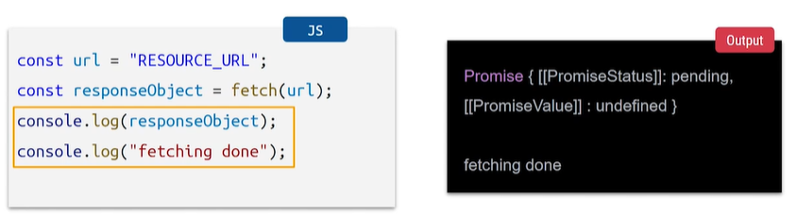

* Fetch(url) = .then emi pettaledu just fetch(url) = oka object ni return chesthundi
* Ah object enti anedi manam print chesi chusam
* Ah object enti ante promise object
* 

**JS PROMISES:**

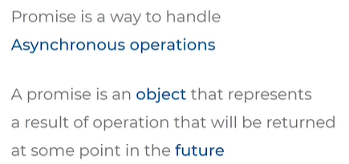

* We deal mostly with Asynchronous operations
* To deal with Asynchronous operations we use JS promises objects
* Asynchronous operations begin avvagane promises ane object ni return chesthundi

**PROMISE STATE:**

* Promise ane obj 3 stages lo untadi
* Pending: Asynchronous operations begin avvagane promise obj return avthundi Asynchronous operations inka pending stage lo undhi
* Fulfilled: Asynchronous operations purpose successful ayithe fulfilled
* Rejected: Asynchronous operations begin chesaka for some reason fail ayithe promse obj reject avthundhi

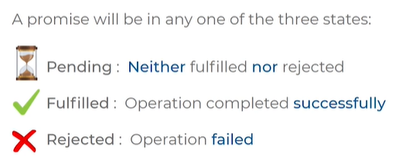

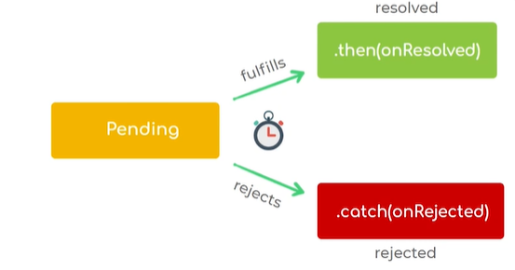

1. call back function when promise object is in stage fulfilled = .then
2. call back function when promise object is in stage rejected =.catch

* Promise object fulfilled ane stage loki vellagane
* We can give a callback function
* Promise object fulfill ayindi kabatti callback function kuda execute avthundi
* Callback function execute avvadanikii successful ga manam .dot then anedi rasthunnam
* Asynchronous function fail ayithe .catch ani call back function ivachu

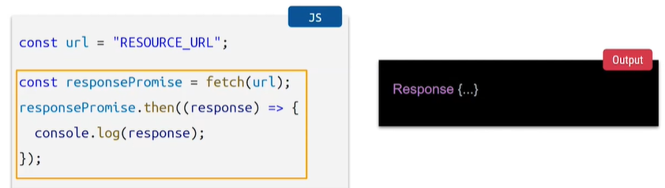

* Fetch(url) = req begin avthundi ,similarly Asynchronous operations begin avthundi and avvagane promise ane obj return avthundi
* Const = lo manam responsePromise annam
* .then = success ayithe callback function execute avvu ani
* Call back function ni arrow function syntax lo rasamu
* Response ane object output

**On failure CallBack:**

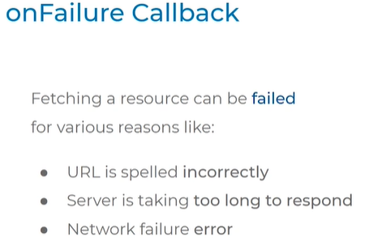

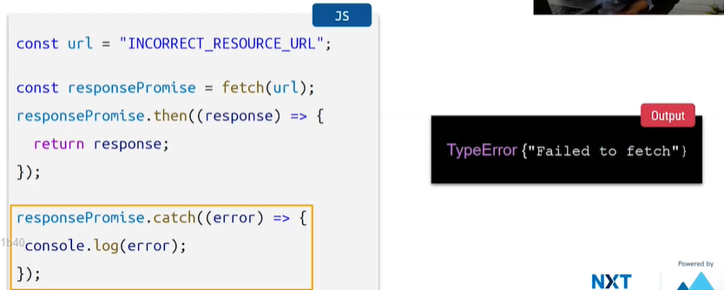

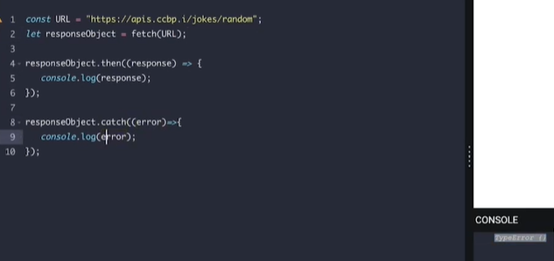

* E paina code promise object successful ga execute ayithe .then lo unna arrow func output lo response ani vasthundi
* Fail ayithe ela typeerror ani vasthundhi
* url is spelled wrongly –in- thisesaru

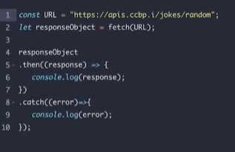

* e syntax kuda follow avachu catc mundu unna front obj thisesamu

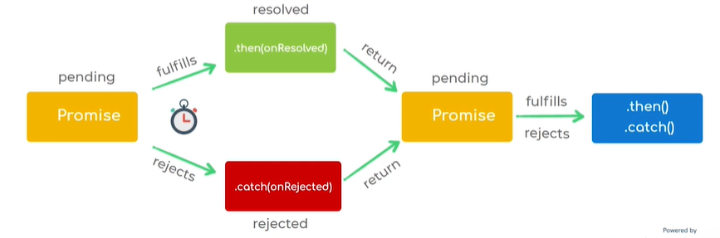

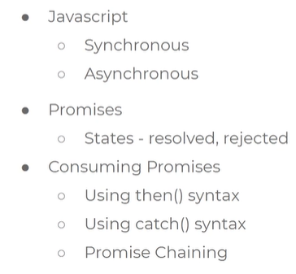

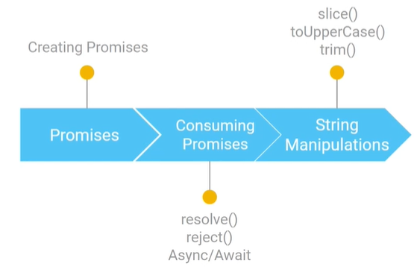

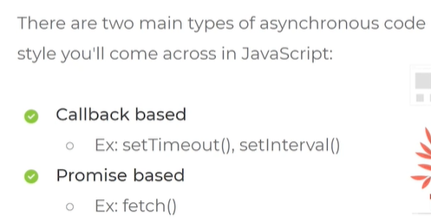

* Asynchronous JS lo unnamethods 2 categories : 1.call back based 2.promise based
* Modern way is return promise based operation
* Call back is oldest way

RETURNING A PROMISE OBJECT: WHAT IS A PROMISE OBJECT AND HOW TO CREATE IT

* Use built in function
* New space promise of callback function
* In call back function 1st arg is Resolve function, 2nd arg is reject function
* Function lopala asynchronus rastham
* Over all its called executor function

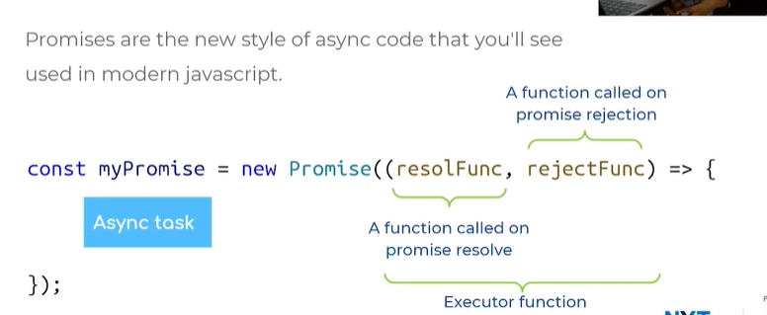

CREATE A PROMISE OBJECT :

* New promise of ani arg pass chesam resolve reject
* Settime out pettam resolve call avvgaane promise anedi fulfilled stage loki velthundi
* Promise obj ki .then ivvagane ah call back function trigger avthundi
* Resolve ki arg laga

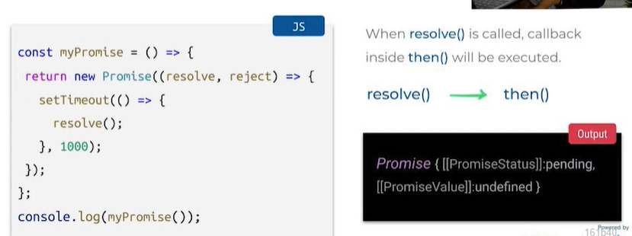

Called reject of

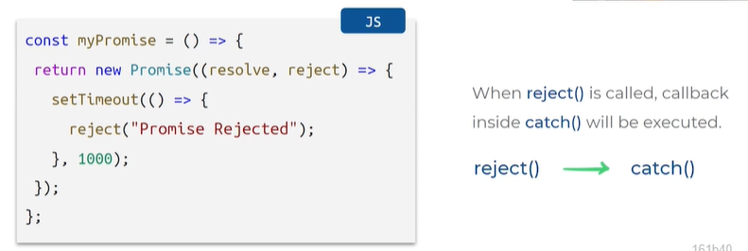



Promise objects ni consume cheskodaniki aync await ni use chestham

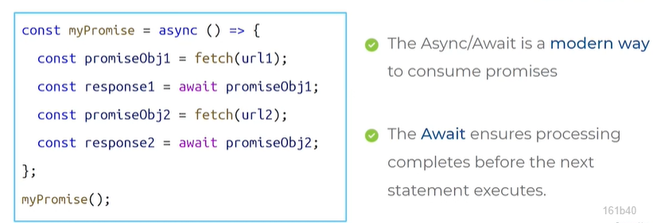

* Async await use chesi oka code rasamu
* Const ki variable petti arrow function rasamu async ki
* Arrow fun lopala fetch(url ) = return promise object
* Wait promise obj1 ani rasamu = promis eobj fulfilled/reject stage lo velle varaku wait chesthudni execute aye varaku

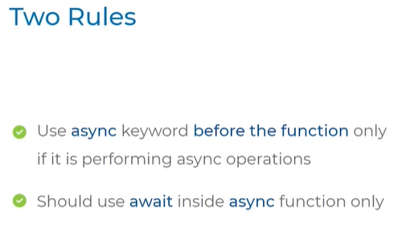

Fetch with aync and await

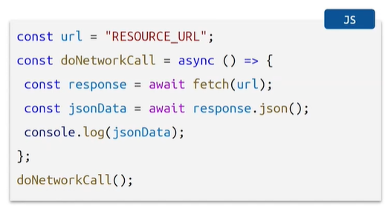

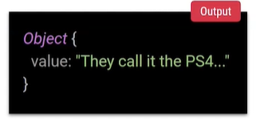

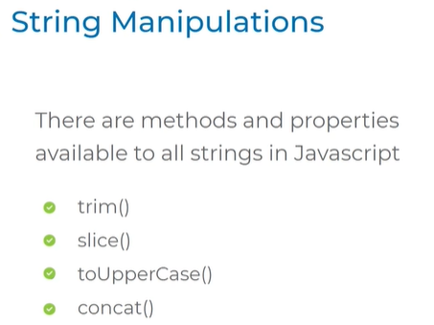

1.trim() = removes white spaces in string

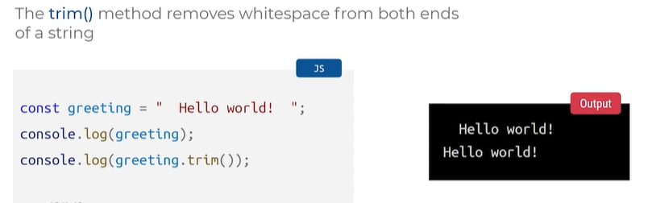

1. String Sliing: startIndex, end index last index is not included

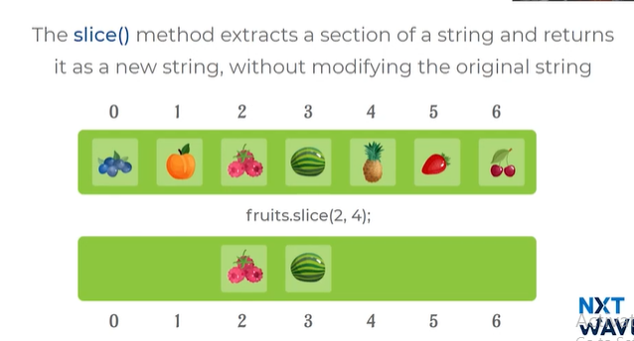

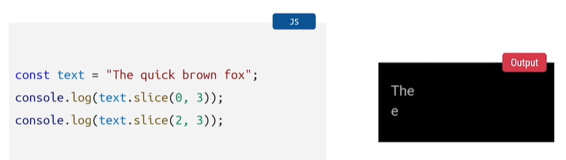

3.Converts string to uppercase

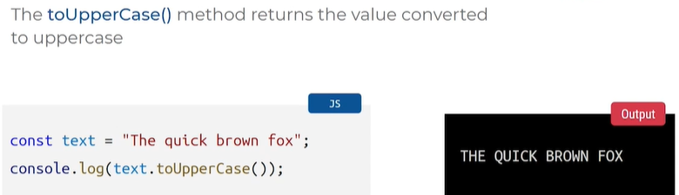

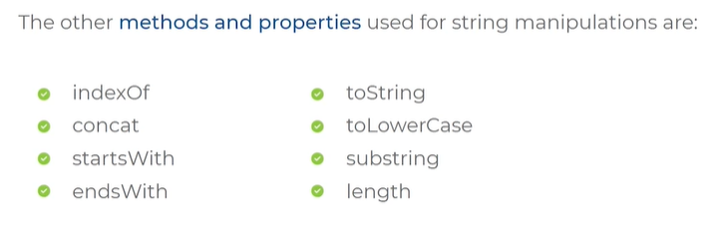

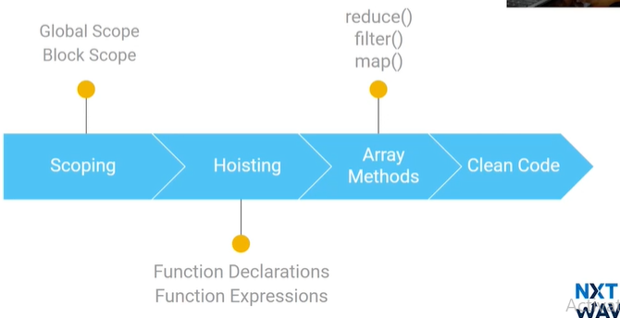

1.Scoping concept

declare chesina Variables entire code lo which regions of code lo accessible ga untayo

2 types: block, global

BLOCK:

Cosnt or let tho variable declare chesi ah variable ni curly braces lo use chessthe vatini block scope antaru

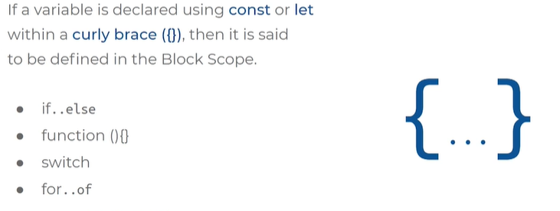

Example:

X variable cannot used outside because it it used in block cannot access if it is in block of code

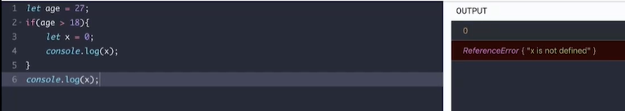

GLOBAL SCOPE : vice versa to block scope

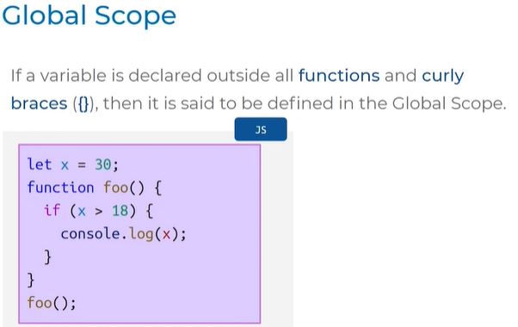

HOISTING CONCEPT :

Left side code is actual code

Function declaration moves upside first function execute avthundi

Result kakunda function first execute avthundi before code excutes

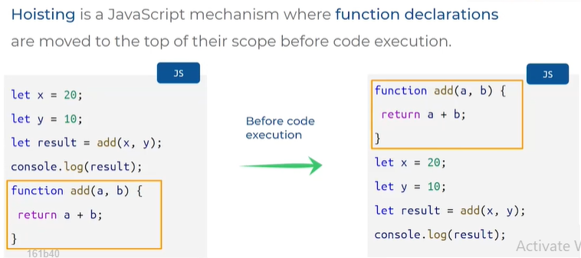

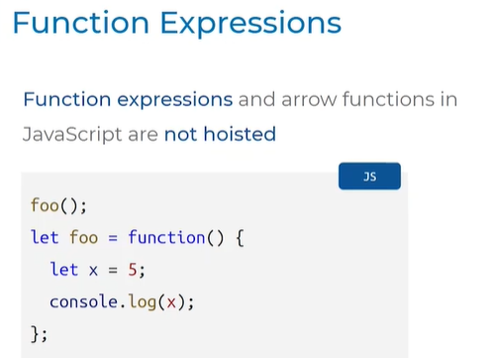

* Function exp or arrow functions ki hoisting applicable avdhu

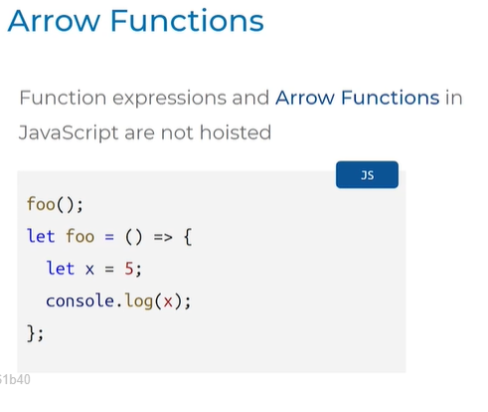

Hoisting function declaration ki applicable, arrow functions and function expressions ki applicable kadu

MORE ARRAY METHODS:

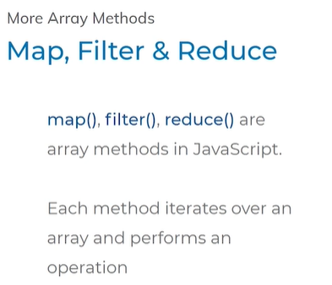

We can iterate on array methods

Map fliter reduce

Examples:

* Map array method
* Square ane operation perform avthundi
* 1 =1
* 2*2 =4

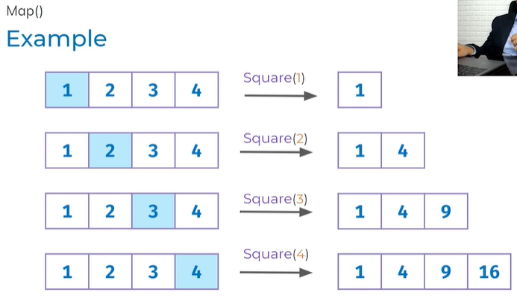

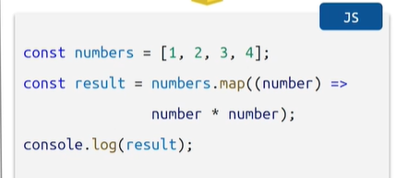

* Variable declared with numbers
* Call back function ichamu number input
* Square chesthunnam

Fliter method:

To fliter some items

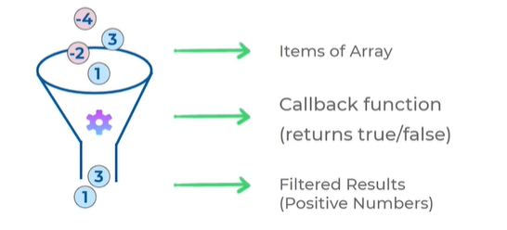

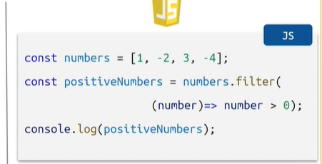

Fliter method lo oka array function use chestham

REDUCE METHOD: addition chesi 10 output isthundi

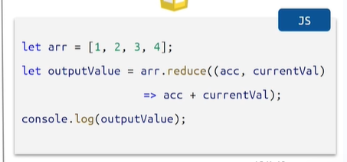

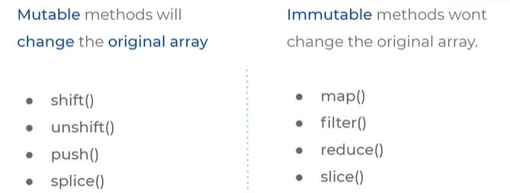

Clean code: